LaACES Program
Critical Design Review Document
for the

PHAT-TACO: Pressure, Humidity, And Temperature Tests And Camera Observations
Experiment
by
Team Philosohook
Prepared by:
Hannah Gardiner Date

Randy Dupuis Date

Bill Freeman Date

Corey Myers Date

Andrea Spring Date
Submitted: 3/25/2011
Reviewed:
Revised:
Approved:
Dr. Guzik: Date

Institution Signoff Date

LAACES Signoff Date

Change Information Page

Title: CDR Document for PHAT-TACO Experiment
Date: 03/29/2011

List of Affected Pages
Page Number | Issue | Date
4 | Rearranged Science background | 3/31/11
4 | Added atmospheric image (3-1) | 3/31/11
8 | Added Radius vs. Altitude image | 3/31/11
18 | Temperature Sensor Interface Circuit Schematic Updated | 4/02/11
19 | Pressure Sensor Interface Circuit Schematic Updated | 4/02/11
19 | Humidity Sensor Interface Circuit Schematic Updated | 4/02/11
21 | Full Circuit Schematic Updated | 4/02/11
43 | Added error calculation to ADC conversions | 4/04/11
29 | Added X,Y, and Z timing calibration flowchart | 4/04/11
41 | Updated Humidity calibration description and add equation to calculate RH | 4/04/11
41 | Added camera timing calibration description to calibration section | 4/04/11
21 | Updated Power Supply section | 4/04/11
16 | Testing procedures updated | 4/04/11
19 | Calibration procedure updated | 4/04/11
61 | Temperature testing procedure updated | 4/13/11

Status of TBDs

TBD  Number | Section | Description | Date  Created | Date Resolved
1 | 4.3.2 | Resistor Value for Pressure Sensor | 3/23/11
2 | 4.3.4 | Size of Fuses for Power Supplies | 4/04/11

Table of Contents
Change Information Page ii
Title: CDR Document for PHAT-TACO Experiment ii
Status of TBDs iii
Table of Contents iv
List of Figures vi
List of Tables vi
1.0 Document Purpose 1
1.1 Document Scope 1
1.2 Change Control and Update Procedure 1
2.0 Reference Documents 1
3.0 Goals, Objectives, Requirements 3
3.1 Mission Goal 3
3.2 Objectives 3
3.2.1 Science Objectives 4
3.2.2 Technical Objectives 4
3.3 Science Background and Requirements 4
3.3.1 Science Background 4
3.3.1.1 Temperature, Pressure, and Humidity of the Atmosphere 4
3.3.1.2 Clouds 6
3.3.1.3 Balloon Expansion 7
3.3.2 Science Requirements 8
3.4 Technical Background and Requirements 9
3.4.1 Technical Background 9
3.4.1.1 Background on different sensors 9
3.4.1.2 Payload Placement 10
3.4.1.3 Precision of measurements 11
3.4.2 Technical Requirements 12
4.0 Payload Design 13
4.1 Principle of Operation 13
4.2 System Design 14
4.2.1 Functional Groups 15
4.2.2 Group Interfaces 15
4.2.3 Traceability 15
4.3 Electrical Design 17
4.3.1 Sensors 17
4.3.2 Sensor Interfacing 17
4.3.3 Control Electronics 20
4.3.4 Power Supply 22
4.3.5 Power Budget 22
4.4 Software Design 24
4.4.1 Data Format & Storage 24
4.4.1.1 BalloonSat Data Storage 24
4.4.1.2 Video Data Storage 25
4.4.2 Flight Software 25
4.4.2.1 Pre Flight 25
4.4.2.2 During Flight program and subroutines 26
4.4.2.3 Post Flight program 30
4.5 Thermal Design 31
4.6 Mechanical Design 32
4.6.1 External Structure 32
4.6.2 Internal Structure 33
4.6.3 Weight Budget 34
5.0 Payload Development Plan 35
5.1 Electrical Design Development 35
5.2 Software Design Development 35
5.3 Mechanical Design Development 35
5.4 Mission Development 35
6.0 Payload Construction Plan 36
6.1 Hardware Fabrication and Testing 36
6.2 Integration Plan 36
6.3 Flight Software Implementation and Verification 37
6.4 Flight Certification Testing 37
6.4.1 System Testing Procedures 38
7.0 Mission Operations 39
7.1 Pre-Launch Requirements and Operations 39
7.1.1 Calibrations 40
7.1.1.1 Calibration Procedures 41
7.1.2 Pre-Launch Checklist 42
7.2 Flight Requirements, Operations and Recovery 43
7.3 Data Acquisition and Analysis Plan 43
7.3.1 Ground Software 43
7.3.2 Ground Software Implementation and Verification 44
7.3.3 Data Analysis Plan 45
8.0 Project Management 47
8.1 Organization and Responsibilities 47
8.2 Configuration Management Plan 48
8.3 Interface Control 48
9.0 Master Schedule 48
9.1 Work Breakdown Structure (WBS) 48
9.2 Staffing Plan 50
9.3 Timeline and Milestones 51
10.0 Master Budget 51
10.1 Expenditure Plan 52
10.2 Material Acquisition Plan 52
11.0 Risk Management and Contingency 53
12.0 Glossary 56
Appendix 57
A.1 Temperature and pressure errors 57
A.2 Lapse rate error propagation: 58
A.3 Errors in the radius measurement: 59
A.4 Balloon Radius equation derivation: 60
A.5 Temperature system testing:……………………………………………………………...61

List of Figures

3-1: Temperature, pressure, and humidity as a function of altitude………………………….…4
3-2: Temperature, pressure, and humidity as a function of altitude 5
3-3: Ascent curves from ACES-16 7
3-4: Balloon Radius vs Altitude………………………………………………………………...8
3-5: Three potential camera positions for viewing the balloon 11
4-1: High level system design 13
4-2: Temperature Sensor Interface 17
4-3: Pressure Sensor Interface 18
4-4: Humidity Temperature Sensor Interface 18
4-5: Camera Interface 19
4-6: Full Circuit Schematic 20
4-7: Flight Power Distribution 21
4-8: Milliamp-Hours Capacity of AA and AAA batteries 22
4-9: Energizer AAA discharge curve 23
4-10: Energizer AA battery capacity 23
4-11: Pre-flight software flowchart 24
4-12: During-flight software flowchart 25
4-13: Start Camera and Stop Camera subroutine flowcharts 26
4-14: Take data subroutines 28
4-15: Post-flight software flowchart 29
4-16: Shows the external structure of the payload 32
4-17: Front internal structure view…………………………………………………………….33
7-1: Balloon Radius calculator…………………………………………………………………42
9-1: Gantt chart showing the overall project timeline 49
A-1: Temperature as a function of altitude……………………………………………………61

List of Tables

3-1: Correlation between temperature and humidity 11
4-1: Traceability matrix 14
4-2: Power budget with camera data from Knoxville College 21
4-3: Meaning and cause of each possible camera status byte 27
4-4: BalloonSat device ranges 29
4-5: Thermal Calculations…..………………………………………………………………....30
4-6: Weight budget 33
7-1: Pre-launch checklist with expected time needed to fulfill each duty..……….……….….41
8-1: Team members, their responsibilities, and email addresses 46
10-1: Master Budget……………………………………………………..………………..…...49
10-2: Expenditure Plan………………………………………………..……………………….50
10-3: Material Acquisition Plan……………………………………..………………………...50
11-1: Risk Management……………………………………………..………………………...51
11-2: Risk Contingency…………………………………………….………………………....52
A-1: Typical errors in radius measurement based on geometry….………………………...…57

1.0 Document Purpose

This document describes the design for the PHAT-TACO: Pressure, Humidity, and Temperature tests and Camera Observations experiment by Team Philosohook for the LaACES Program. It fulfills part of the LaACES Project requirements for the Critical Design Review (CDR) to be held March 29, 2011.

1.1 Document Scope

This CDR document specifies the scientific purpose and requirements for the video, temperature, pressure, and humidity experiment and provides a guideline for the development, operation and cost of this payload under the LaACES Project. The document includes details of the payload design, fabrication, integration, testing, flight operation, and data analysis. In addition, project management, timelines, work breakdown, expenditures and risk management are discussed. Finally, the designs and plans presented here are preliminary and will be finalized at the time of the Critical Design Review (CDR).

1.2 Change Control and Update Procedure

Changes to this CDR document shall only be made after approval by designated representatives from Team Philosohook and the LaACES Institution Representative. Document change requests should be sent to Team members and the LaACES Institution Representative and the LaACES Project.

2.0 Reference Documents

[1] U.S. Standard Atmosphere, 1976, U.S. Government Printing Office, Washington, D.C., 1976.

[2] Oolman, Larry. "Atmospheric Soundings." Wyoming Weather Web. Web. 28 Nov. 2010. <http://weather.uwyo.edu/upperair/sounding.html>.

[3] "Earth's Atmosphere." NASA. Web. 23 Nov. 2010. <http://www.nasa.gov/audience/
forstudents/9-12/features/912_liftoff_atm.html>.

[4] "Layers of the Earth's Atmosphere: Troposphere, Stratosphere, Mesosphere, Thermosphere, and Exosphere." Windows to the Universe. Web. 23 Nov. 2010. <http://windows2universe.org/earth/Atmosphere/layers.html>.

[5] Gyatt, Graham. "The Standard Atmosphere." Atmosculator. 24 Apr. 2009. Web. 28 Nov. 2010. <http://www.atmosculator.com/The Standard Atmosphere.html>.

[6] Shelquist, Richard. "An Introduction to Air Density and Density Altitude Calculations." Shelquist Engineering. 2 Aug. 2010. Web. 28 Nov. 2010. <http://wahiduddin.net/calc/
density_altitude.htm>.

[7] "Cloud Types." Windows to the Universe. Web. 23 Nov. 2010. <http://windows2universe.
org/earth/Atmosphere/clouds/cloud_types.html>.

[8] "Cloud." Atmosphere. Cislunar Aerospace, Inc., 02 Jul 1997. Web. 01 Nov 2010. <http://wings.avkids.com/Book/Atmosphere/instructor/clouds-01.html>.

[9] "Types of Temperature Sensors." About Temperature & Moisture Sensors Devices & Uses in Measurement. Web. 23 Nov. 2010. <http://www.temperatures.com/sensors.html>.

[10] "Fundamentals of Pressure Sensor Technology." Sensors Magazine. Web. 23 Nov. 2010. <http://www.sensorsmag.com/sensors/pressure/fundamentals-pressure-sensor-technology-846>.

[11] "Choosing a Humidity Sensor: A Review of Three Technologies." Sensors Magazine. Web. 23 Nov. 2010. <http://www.sensorsmag.com/sensors/humidity-moisture/choosing-a-humidity-sensor-a-review-three-technologies-840>.

[12] "Camera Selection Advice Guide." Sensorland. N.p., 2010. Web. 30 Oct 2010. <http://www.sensorland.com/HowPage066.html>.

[13] Fetkowitz, Paul. "Sounding Balloons." Kaymont Meteorological Balloons. Web. 07 Feb. 2011. <http://www.kaymont.com/pages/sounding-balloons.cfm>

[14] Fetkowitz, Paul. "Shape and Quality." Kaymont Meteorological Balloons. Web. 14 Mar. 2011. <http://www.kaymont.com/pages/shape.cfm>

[15] Benson, Tom. "Shape Effects on Drag." NASA. 23 Aug. 2010. Web. 07 Feb. 2011. <http://www.grc.nasa.gov/WWW/K-12/airplane/shaped.html>.

[16] Everett, Carter. "Generating Gaussian Random Numbers, Taygeta Scientific Inc." Taygeta Scientific Incorporated. Web. 04 Mar. 2011. <http://www.taygeta.com/random/gaussian.html>.

[17]Sept. 2010. “1230 Ultratable”. Measurement Specialties. Web. Mar 24, 2011. <http://www.meas-spec.com/downloads/1230.pdf>.

[18] Honeywell Internatinal Inco. Electronic Components Distributor | DigiKey Corp. | US Home Page. Tech. no. HIH-5030/5031 Series. Honeywell Internatinal Inco., Mar. 2010. Web. 01 Mar. 2011. <http://www.digikey.com/>

[19] "Zx1 Pocket Video Camera, Digital Video Camera, HD Video Camera - Kodak Online." Digital Cameras, Digital Photo Frames, Video Cameras, Printers & Accessories - Kodak Store. Web. 01 Mar. 2011. <http://store.kodak.com/store/ekconsus/en_US/pd/
Zx1_Pocket_Video_Camera/productID.145117100>.

[20] Bullard, Denae, DeAnna Anderson, Munshi Idris, and Caitlin Johnson. PACER Program Flight Readiness Review Document for the Measuring Temperature, Pressure, and Humidity and Increasing Altitudes Experiment. Tech. Print.

[21] "Energizer Technical Information." Energizer Technical Information. Web. 02 Feb. 2011. <http://data.energizer.com/SearchResult.aspx>.

[22] LaACES Management. “LaACESSteadyState_Flight.” Excel Spreadsheet. Dr. T. G. Guzik.

[23] 2002. “1N457/A”. Fairchild Semiconductor. Web. Mar. 18, 2011. <
http://www.
datasheetcatalog.org/datasheet/fairchild/1N457.pdf>.

[24] “Activity E7c. Sensors and Signal Conditioning.” Fall 2010. LaACEs. LSU. Baton Rouge, La.

[25] Breuer, Hans. "Dia." Home - GNOME Live! 1 Jan. 2011. Web. 24 Mar. 2011. <http://live.
gnome.org/Dia>.

[26] Bolton, David. “The Computation of Equivalent Potential Temperature”. Monthly Weather Review. Vol.108, No. 7 (july) p. 1047.

[27] Aug. 2010. “3299 - 3/8 ” Square Trimpot Trimming Potentiometer”. Bourns Inc. Web. April 4, 2011. <http://www.bourns.com/pdfs/3299.pdf>.

[28] "Atmospheric Gases, Temperature, and Pressure." Wyckoff School District of NJ. Web. 05 Apr. 2011. <http://www.wyckoffschools.org/eisenhower/teachers/chen/atmosphere/
earthatmosphere.htm>.

3.0 Goals, Objectives, Requirements

3.1 Mission Goal

To study the layers of the atmosphere using an instrumented sounding balloon flown in East Texas during May and to analyze the balloon and the environment surrounding the payload in order to study the relationship between the temperature and humidity profiles acquired during flight.

3.2 Objectives

The overall objective is to measure and record humidity, pressure, and internal and external temperature on a sounding balloon flight while taking video of the flight.

3.2.1 Science Objectives

- Determine at what altitude the Tropopause is located
- Characterize temperature, pressure, and humidity in layers
- Determine if the payload passes through clouds
- Determine balloon diameter as a function of altitude

3.2.2 Technical Objectives

- Build a working payload that can withstand conditions of a balloon flight
- Record temperature, pressure, and relative humidity for the duration of flight
- Determine at what altitude the payload enters and exits clouds
- Determine the radius of the balloon at several altitudes
- Document the PHAT-TACO experiment

3.3 Science Background and Requirements

3.3.1 Science Background

3.3.1.1 Temperature, Pressure, and Humidity of the Atmosphere

The atmosphere of the Earth consists of four layers (Troposphere, Stratosphere, Mesosphere, and Thermosphere) and four transition layers (Tropopause, Stratopause, Mesopause, Thermopause), determined by a combination of temperature change, chemical composition, and density. Figure 3-1 shows the layers of the atmosphere.

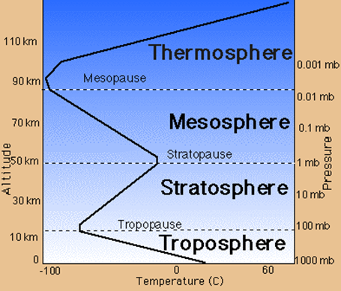
The Troposphere starts at the Earth’s surface and extends upward 15 kilometers, making it the lowest layer of the atmosphere. This layer contains most of the gas in the atmosphere making it the densest layer. The temperature starts at an average of 17°C on the surface and decreases to -52°C at the Tropopause, the boundary that separates the Troposphere from the layer above [3]. The height of the Tropopause varies depending on the latitude, season and time of day. The Tropopause is approximately 20 km above sea level near the equator [4]. The combination of Troposphere and Tropopause is called the lower atmosphere [3].
Figure 3-1 Temperature, pressure, and humidity as a function of altitude [28]

The Stratosphere, the second layer of the atmosphere, ranges from 15 to 50 kilometers. Because of higher altitude, the Stratosphere contains less humidity and has a lower pressure than the Troposphere. The temperature of the Stratosphere increases from -52° to -3° C, starting at the Tropopause and ending at the Stratopause, due to the presence of the ozone layer, made from a special form of oxygen called ozone. The ozone layer absorbs the ultraviolet radiation from the sun and causes an increase in temperature [4].

National Oceanic and Atmospheric Administration (NOAA), National Aeronautics and Space Administration (NASA), and the United States Air Force (USAF) developed the “US Standard Atmosphere” in 1976. Using only the ideal gas law and the hydrostatic equilibrium law, they produced a mathematical model of the atmosphere. This model is “a hypothetical vertical distribution of atmospheric temperature, pressure, and density…representative of year-round mid-latitude conditions” [1]. Using this model and prior studies of the atmosphere, we can predict the range and precision of measurements that we must take.

The US Standard Atmosphere predicts that the Tropopause should be between 11 and 20 km, however this is only an approximation and the actual location of the Tropopause changes by season and latitude. More accurately, the US Standard Atmosphere defines layers by the rate of change of temperature with altitude, or lapse rate. The lapse rate is -6.5 °C/km in the Troposphere, 0.0 °C/km in the Tropopause and 1.0 °C/km in the lower Stratosphere. We can determine which layer of the atmosphere we are in by measuring lapse rate and comparing the expected value to the lapse rate value predicted by the US Standard Atmosphere.

Figure 3-2: Temperature (A), pressure (B), and humidity (C) as a function of altitude from NOAA
data taken on May 23, 2010 from Fort Worth, Texas [2]

There are several trends present in the temperature profile of the NOAA data in Figure 3-2A. In the first section, between 0 and 16 km, lies the Troposphere, where the temperature decreases linearly. In the second section, between 16 and 18 km, lies the Tropopause, where the temperature does not change. In the next layer, between 18 and 32 km, lies the lower Stratosphere, where the temperature increases linearly. Based on U.S. Standard Atmosphere,we expect the absolute maximum temperature range to be between 45 and -86 ºC, but a more reasonable range based on prior data, as shown in Figure 3-2A, and the summer launch date would be between 30 and -70 °C [1, 2].

The US Standard Atmosphere models the pressure as a function of altitude from sea level to the Stratosphere [1, 5]. Because temperature does not change in the Tropopause, the US Standard Atmosphere uses three equations, one for each layer of the atmosphere. In Figure 3-2B, the NOAA data matches the expected values for pressure. The relative error averages 4% but increases in the Troposphere. The pressure ranges from 1 to 0.008 atm. To measure any deviations from the US Standard Atmosphere in the pressure profile, the uncertainty of the pressure must be ±0.004 atm.

In calculating the parameters in the standard atmosphere, the model assumes the air is completely dry, with 0% relative humidity[1]. Water vapor weighs less than the average air molecule. When the air is humid, its molecular weight decreases. The US Standard Atmosphere considered molecular weight to be a constant up to 84 km. Since humidity is not constant with altitude, it is important to study and characterize this property and how it influences the temperature and pressure of the atmosphere [6].

The humidity of the atmosphere does not have a standard profile. The NOAA data in Figure 3-2C shows the various features of the profile of humidity versus altitude. The data ranged from 100 to 8 percent relative humidity (%rel). In order to properly characterize atmospheric humidity, we must take data that shows all of the changes in the profile.

As shown in Figure 3-2C, humidity changes the most drastically in the first 10 km. The change in humidity peaks at 42 percent per kilometer. Since we do not understand the causes of the features in the humidity profile, we must take accurate humidity data with a high temporal resolution, especially at the beginning of the flight. From sea level to 11 km, data must be taken at least 30 times per kilometer or 10 times per minute assuming a 1,000 feet per minute ascent rate. Above 11 km, we do not need to take data at such a high frequency, because the rate of change in the humidity decreases. To simplify the software, we will only use one data acquisition rate, which will be one data point every six seconds for all sensors.

3.3.1.2 Clouds

Almost all clouds form in the Troposphere. Different cloud types form at different altitudes because of the varying density and temperature of the Troposphere. Clouds found near the surface (0 to 2 kilometers) include Cumulus and Cumulonimbus and are characterized by higher humidity. Clouds found higher up (2 to 7 kilometers) include Altostratus and Altocumulus. The third and highest (5 to 13 kilometers) cloud forms include Cirrus clouds [7].

There are two major types of clouds. The first type, clouds of vertical development, form because of the condensation of rising air. The second type, clouds that are layered, form because of the condensation of non-rising air [8].

Due to cloud composition, if our payload passes through a low cloud we expect the humidity to increase drastically but the temperature to remain relatively the same. However, if it passes through a high cloud, we expect the humidity to be mostly unaffected and the temperature to drop because of the surrounding ice crystals.

3.3.1.3 Balloon Expansion

The entire ACES program hinges on the performance of a simple sounding balloon. The hopes and dreams of every ACES participant hinges on the lift from this balloon. Therefore, it is important to characterize the performance of the balloon.

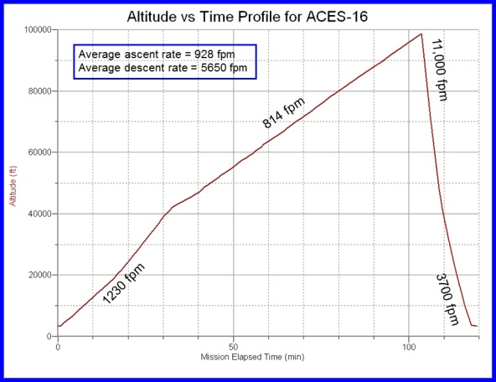
Figure 3-3: Ascent curve from ACES-16

Figure 3-3 shows the ascent curve of ACES-16. The ascent rate is supposed to be a constant, yet the ascent profile shows a change in ascent rate at an altitude of 40,000 feet.

We will use a Kaymont 3000 gm sounding balloon for lift. This balloon has a bursting radius of 13.00 meters at 37.9 km (124,000 ft) and 0.0037 atm [13]. Kaymont balloons are designed to keep a “spherical shape…[and] consistent ascent rates under all conditions” [14].

When the balloon reaches constant velocity, all the forces acting on the balloon are equal. By setting the buoyant force of the balloon equal to the drag force and the weight, we can derive a relationship between expected radius and altitude (full derivation is in the appendix).
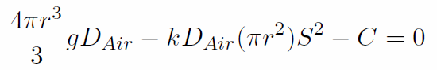

Figure 3-4: Balloon Radius vs Altitude

In this equation, D_{Air} is the density of air in kg/m³, g is gravitational acceleration in m/s², C is the weight of the balloon, payloads and Helium in newtons, and S is the speed of the balloon in m/s. The density of air can be estimated from the US Standard Atmosphere model, radius of the balloon will be measured from the video, the weight of the balloon, payloads and Helium should be known before launch, g is 9.81m/s², k is a geometrical factor which is between 0.07 and 0.5 for spheres [15], and the speed can be calculated from GPS data. The radius and density of air should be the only factors that change with height. Figure 3-4 shows the expected radius as a function of altitude using 0.5 for k.

3.3.2 Science Requirements

- We shall measure temperature, pressure, and humidity of the atmosphere every six seconds and record a timestamp for each of these measurements
- We shall calculate altitude using a timestamp from each data point and GPS data from the flight
- We shall identify layers of atmosphere using temperature lapse rate measurements
- We shall compare measured pressure with expected pressure of the US Standard Atmosphere
- We shall characterize features in the humidity profile
- We shall identify if the payload passes through a cloud and when it exits a cloud
- We shall measure radius of the balloon as a function of altitude and compare our measurements to the theoretical relationship discussed in the science background
- We shall determine any effects of passing through a cloud on temperature, pressure, and humidity readings
- We shall calculate altitude during the video using timestamps of the video recorder

3.4 Technical Background and Requirements

3.4.1 Technical Background

3.4.1.1 Background on different sensors

To study the atmospheric layers the payload needs to be able to measure the various atmospheric conditions. Each characteristic: temperature, pressure, and humidity, requires a specific sensor, which will be chosen based on accuracy of measurements, expected range during flight, and cost.

Temperature sensors fall into two categories: contact sensors and non-contact sensors. Contact sensors work by measuring the difference of temperature between itself and its surroundings. There are different types of contact sensors, thermocouples, resistant temperature detectors (RTDs), and thermistors. Thermocouples work based on the Seebeck effect, the conversion of temperature differences into voltages. Thermocouples do not need batteries and can measure a wide range of temperatures. RTDs work by measuring the resistance increase with temperature. RTDs are the most accurate temperature sensors and they are easy to recalibrate, but they have a smaller range than thermocouples, are more expensive, and are not very sturdy. Thermistors work the same way as RTDs but are made of different materials. RTDs are usually made of pure metals and thermistors are made of a ceramic or polymer. Thermistors have a smaller range than RTDs but are extremely accurate. Non-contact sensors measure the thermal radiant power of the infrared or optical radiation that they receive from a target’s surface. Non-contact sensors cannot detect the temperature of a gas therefore; sensors would not be useful in studying the atmosphere [9].

Pressure sensors function by using different mechanical elements that designed to deflect when pressure acts on the system. An electrical output can be obtained by measuring the deflection and transducing the measurement to an electrical quantity. There are several types of pressure sensors: potentiometric sensors, inductive sensors, capacitive sensors, piezoelectric sensors, and strain gauge sensors. Potentiometric sensors will sense the pressure using a Bourdon tube, capsule, or bellow, and the pressure applied will change the resistance. In short, is a potentiometer that changes due to the pressure. These sensors are low cost, but have high repeatability errors. Inductive sensors measure movement of a diaphragm by changes in inductance. Capacitive sensors use a variable capacitor to measure the pressure. One plate of the capacitor is a diaphragm and the other plate of the capacitor is stationary. When pressure is applied, the diaphragm deflects which changes the distance between the two plates causing the capacitance to change. Piezoelectric elements consist of metalized quartz or ceramic material. These elements convert stress into an electric potential. These sensors only provide output when the input is changing so they only measure varying pressures. Strain gauge sensors use a metal diaphragm with strain gauges attached to it. The most common type of these sensors is piezoresistive integrated semiconductors. These sensors incorporate four piezoresistors arranged in a Wheatstone Bridge. When stress is applied, the resistance changes and the pressure relates to the difference in the output voltages of the bridge. Temperature affects the output of these sensors [10].

There are three types of humidity sensing technologies: capacitive, resistive, and thermal conductive. Capacitive sensors consist of a substrate, usually glass, ceramic, or silicon. These Sensors constructed by placing a thin film of metal oxide or polymer between two conductive electrodes on the substrate. The sensor has coating to protect the circuitry from humidity and contamination. These sensors have a capacitive output that changes linearly with the relative humidity. These sensors can function in high temperature and can fully recover from condensation. Resistive humidity sensors measure humidity by using the change in impedance across a hygroscopic medium. Hygroscopy is the ability of a substance to attract water molecules from the surrounding environment. The change in impedance relates to the relative humidity in an inverse and exponential relationship. These sensors operate in temperatures ranging from -40 to 100 °C. Thermal conductive humidity sensors measure the absolute humidity by using the difference of the thermal conductivity of dry air and of air containing water vapor. These circuits operate in temperatures up to 300 °C but the temperature affects the output voltage [11].

High Definition (HD) video comes in two different resolutions, 720p at 1280x720 pixels and 1080p at 1920x1080 pixels. The 720p resolution uses 2-3 MB/s and the 1080p resolution uses 5-6 MB/s. The data rate varies because video cameras use a compression algorithm that changes storage based on what one is recording.

The video camera point upwards so that we can see when our payload moves into and out of clouds in addition to determining the balloon radius. Knowing the distance from the camera to the balloon, the size of the balloon will be determined by counting the number of pixels contained in the balloon’s diameter. Calibration data will provide a conversion from pixels into meters. We will use screenshots from the video at several heights and create a graph of radius vs. height. While the balloon is passing through a cloud, the balloon will most likely become obscured. Since we do not need the balloon’s radius at every frame, the clouds will not interfere with our data.

3.4.1.2 Payload Placement

If the fully inflated balloon took up the full width of the image (1280 pixels), the angular resolution would give us 1300cm/1280px = 1.02 cm/pixel. At launch, the balloon will be near 200 cm, which will take up about 196 pixels.

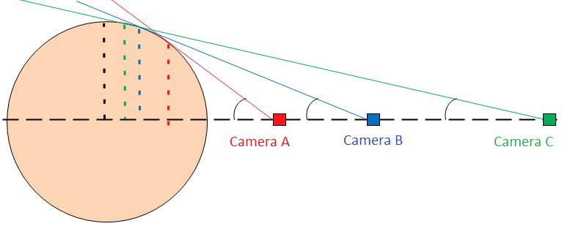
θ
R
r
θ
θ
r
r
Figure 3-5: Three potential camera positions for viewing the balloon

The position of the camera is critical. The camera must be far enough away to accurately measure the size of the balloon. If the camera is too close, the apparent size of the balloon is not correct as described graphically in Figure 3-5. Camera A is too close to the balloon because the apparent radius (dashed red line) is much smaller than the actual radius (dashed black line). As cameras B and C show, the farther away the camera, the closer the measured radius will be to the actual radius of the balloon. There is a trigonometric relationship between camera distance and apparent radius.
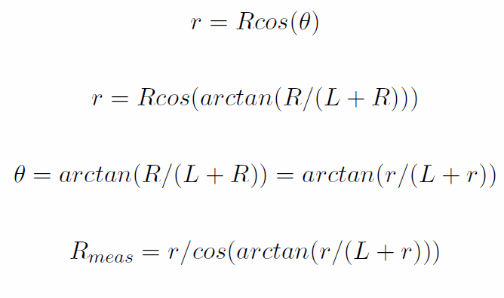
R is the actual radius of the balloon (black dashed line), θ is the viewing angle (black arc), r is the apparent radius measured by the camera (dashed lines), L is the distance from the edge of the balloon to the camera, and R_{meas} is the final radius after taking into account the geometry of the balloon

The payload directly above the Philosohook payload will be obstructing part of the view. The angle blocked by a 17 cm square payload would be given by the following formula:

θ_{b} = arctan(8.5/L_{p})

θ_{b} is the angle blocked in one dimension and L_{p} is the distance to the next payload in cm. A distance of 50 cm will block 10 degrees, 75 cm will block 6 degrees, and 100 cm will block 5 degrees. Optimal placement will be determined on the day of the launch.

3.4.1.3 Precision of measurements

The correlation coefficient of two sets of data is indicative of how well one parameter influences the other. The percentage of correlation is found by squaring the correlation coefficient and multiplying by 100. A correlation of 80 percent is very strongly correlated, while 25 percent is a very poor correlation. In the NOAA data discussed previously, between 0 and 6 km, the temperature and humidity have a correlation of 80 percent, which is a very strong correlation. The purpose of measuring humidity is to see its effects on other properties. By assuming that our errors will follow a Gaussian distribution, we can add “fake” errors to the data with a set uncertainty [16]. After adding in these errors we measure the correlation again. If there is still a correlation, then our data can have that much uncertainty and still be able to measure this correlation.
 |  | Temperature Uncertainty in C
 |  | 0.1 | 0.3 | 0.6 | 0.9 | 1.2 | 1.5 | 2 | 2.5 | 3 | 4
Humidity  Uncertainty in % rel | 0.5 | 80 | 78 | 76 | 72 | 67 | 62 | 52 | 43 | 35 | 23
 | 1 | 80 | 78 | 76 | 72 | 67 | 62 | 52 | 44 | 35 | 23
 | 2 | 80 | 78 | 76 | 72 | 67 | 62 | 53 | 44 | 36 | 23
 | 3 | 79 | 78 | 75 | 71 | 67 | 62 | 53 | 44 | 36 | 23
 | 4 | 79 | 78 | 74 | 71 | 67 | 61 | 52 | 43 | 36 | 23
 | 5 | 78 | 77 | 74 | 71 | 66 | 61 | 52 | 43 | 35 | 23
 | 6 | 77 | 76 | 73 | 70 | 65 | 60 | 52 | 43 | 35 | 23
 | 7 | 76 | 75 | 72 | 69 | 65 | 60 | 51 | 42 | 35 | 23
 | 8 | 74 | 74 | 71 | 68 | 64 | 59 | 50 | 42 | 34 | 22
 | 9 | 73 | 72 | 70 | 67 | 62 | 58 | 49 | 41 | 34 | 22
Table 3-1: Correlation between temperature error and humidity between 0 and 6 km from NOAA data taken on May 23, 2010 from Fort Worth, Texas [2]

Table 3-1 shows how Gaussian uncertainties influence the correlation between temperature and humidity. The green shading with bold numbers is between 100 and 75 percent correlated, the yellow shading with italicized numbers is between 74 and 60 percent, and the red shading with underlined text and dotted background are below 59 percent correlated. The optimal uncertainties would be ±0.6 °C for temperature and ±3 %rel for humidity.

3.4.2 Technical Requirements

- The payload’s cost shall not exceed $500
- The payload’s mass shall not be greater than 500 g
- The payload shall be able to be attached to the weather balloon using strings 17 cm apart
- The payload shall have a temperature sensor to measure temperatures between 30 and -70 °C on the outer side of the payload with an uncertainty of ± 0.6 ºC
- The payload shall have a temperature sensor to measure temperatures between 30 and -70 °C on the inside of the payload with an uncertainty of ± 0.6 ºC
- The payload shall have a pressure sensor to measure pressures between 1 and 0.008 atm with an uncertainty of ± 0.004 atm
- The payload shall have a humidity sensor to measure humidity between 100 and 0 %rel with an uncertainty of ± 3%rel
- The sensors on the payload shall take readings once every 6 seconds
- The payload shall provide power to the electrical components
- A conditioning circuit shall be used to condition the signals received from the sensors into signals that are readable by the Analog to Digital Convertor (ADC)
- The payload shall survive liftoff, turbulence of flight, and landing
- We shall work with LaACES management and place our payload in an optimal position to view the balloon
- Achieve FRR, and final payload on time as specified by LaACES management

4.0 Payload Design

The payload and its components must be able to withstand flight up to an altitude of 100,000 feet, including the ability to withstand and function at temperatures between -70 and 30 °C and pressures between 0.008 and 1 atm. The electronic components of the payload will reside inside of a box made out of pink insulation foam, which is then wrapped in aluminized Mylar to protect the components from extreme temperatures. All of the components and the foam box will weigh less than 500 grams. The payload will attach to the balloon by two holes drilled into the side 17 cm apart.

4.1 Principle of Operation

The payload will measure internal and external temperature, internal pressure, and external humidity as well as provide video of the flight. All of these sensors connect to their own power source and the BalloonSat for data acquisition with wires for both the external temperature and humidity sensors to reach the outside of the payload. The camera will have its own power source and memory space. The camera and internal temperature and pressure sensors will reside on the inside of the payload.

4.2 System Design

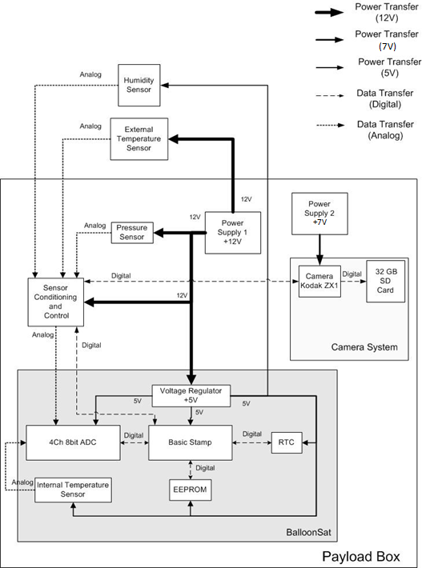

Figure 4-1: High level system design

4.2.1 Functional Groups

Our system contains several different major components. One of the main components is the control system. The BalloonSat serves as an attachment unit, to which the rest of the devices will connect. It controls, reads, and stores the data from the sensors. In order to send commands to all the sensors, all programs written into the Basic Stamp. The EEPROM will record all data, except for video, which has its own internal memory. Detector systems will contain all of our sensors. Power source 1 will power the control system and sensors while power source 2 will power the camera. The In-Flight Data Storage system will store the data during the flight. The post-flight data system will store and analyze the data after the flight. Figure 4-1 shows how each of the systems are connected.

4.2.2 Group Interfaces

The connections between the payload systems depend on which systems are communicating. The control system receives a 12V input from Power Supply 1; in addition, it receives data from the sensor system. The control system also sends data and a 5V output voltage to the In-Flight Data Storage System. The camera will connect to Power Supply 2 because it draws far more current than the rest of the components, which provides 7V.

4.2.3 Traceability

Mission Goal:
To study the layers of the atmosphere using an instrumented sounding balloon flown in East Texas during May and to analyze the balloon and the environment surrounding the payload in order to study the relationship between the temperature and humidity profiles acquired during flight.
Objective | Requirement | Design Element
Determine at what altitude the Tropopause is located | - We shall calculate altitude using a timestamp from each data point and GPS data from the flight  - We shall identify layers of atmosphere using temperature lapse rate measurements  - We shall calculate altitude during the video using timestamps of the video recorder | EEPROM, Real time clock,  Temperature sensor
Characterize temperature, pressure, and humidity in layers | - We shall compare measured pressure with expected pressure of the US Standard Atmosphere  -We shall measure temperature, pressure, and humidity of the atmosphere every six seconds and record a timestamp for each of these measurements | Temperature, pressure, and humidity sensor
Use sensor data to determine if the payload passes through clouds | - We shall characterize features in the humidity profile  - We shall identify if the payload passes through a cloud | Camera, temperature and humidity sensors
Determine balloon diameter as a function of altitude | - We shall measure radius of the balloon as a function of altitude and compare our measurements to the theoretical relationship discussed in the science background  - We shall determine any effects of passing through a cloud on temperature, pressure, and humidity readings | Camera
Build a working payload that can withstand conditions of a balloon flight | - The payload’s cost shall not exceed $500  - The payload’s mass shall not be greater than 500g  - The payload shall be able to be attached to the weather balloon using strings 17 cm apart  - The payload shall provide power to the electrical components  - A conditioning circuit shall be used to condition the signals received from the sensors into signals that are readable by the Analog to Digital Convertor  - The payload shall survive the liftoff, turbulence of flight, and landing | All team members
Record temperature, pressure, and relative humidity for the duration of flight | - The payload shall have a temperature sensor to measure temperatures between 30 and -70 °C on the outer side of the payload with an uncertainty of ± 0.6 ºC  - The payload shall have a temperature sensor to measure temperatures between 30 and -70 °C on the inside of the payload with an uncertainty of ± 0.6 ºC  - The payload shall have a pressure sensor to measure pressures between 1 and 0.008 atm with an uncertainty of ± 0.004 atm  - The payload shall have a humidity sensor to measure humidity between 100 and 0 %rel with an uncertainty of ± 3 %rel  - The sensors on the payload shall take readings once every 6 seconds | Temperature, pressure, and humidity sensor
Determine at what altitude the payload enters and exits clouds | - The payload shall have a humidity sensor to measure humidity between 100 and 0 %rel with an uncertainty of ± 3 %rel | Temperature and humidity sensors, Camera, real time clock
Determine the radius of the balloon at several altitudes | - We shall work with LaACES management and place our payload in an optimal position to view the balloon | Camera
Document the PHAT-TACO experiment | -Achieve PDR, CDR, and FRR on time as specified by LaACES management | All team members
Table 4-1: Traceability matrix

4.3 Electrical Design

4.3.1 Sensors

The payload will require four sensors, one to measure external temperature, one to measure internal temperature, one to measure pressure, and one to measure humidity. The basis for choosing sensors includes cost, sensing range, accuracy, mass, and integration. The payload must have a mass less than 500g, so the sensors chosen need to be small enough to fit inside the payload and add as little mass as possible.

The BalloonSat has a temperature sensor attached to it, which will measure the internal temperature of the payload. A 1N457 will measure the external temperature of the payload. The 1N457 is a small signal p-n junction diode [23]. A diode can be used to measure temperature by measuring the diode’s forward bias voltage. The forward bias voltage of a diode varies linearly with temperature, due to the diode’s temperature coefficient [24]. This sensor consumes little power and can operate linearly for temperatures from -65ºC to 200ºC [23].

The model 1230 series pressure sensors are a set of sensors made by Measurement Specialties. This series can measure different ranges of pressures from 2psi to 100psi. Since the payload only requires a maximum of 1atm (14.7 psi) so a 15psi absolute pressure sensor from this series will be used. These resistors are composed of piezoresistors arranged in a wheatstone bridge and the difference in the output voltages from the bridge relates to the pressure. These sensors have circuitry to compensate for the temperature’s effect on the piezoresistors, which ranges from -20ºC to 85ºC. These sensors also contain an internal resistor used to set the gain of the external conditioning circuitry [17].

The HIH-5031 sensor senses Relative Humidity (RH). The HIH-5031 has a “covered, condensation-resistant, integrated circuit humidity sensor with a hydrophobic filter”. The RH sensor uses a capacitive sensing element with on-chip integrated signal conditioning. The sensing element's construction provides resistance to most hazardous conditions. The humidity sensor has three leads: input voltage, output voltage, and ground. These sensors operate between 2.7 and 5.5V with a maximum current of approximately 0.5mA. [18]

A Kodak Zx1 pocket video camera will record video of the flight. The video camera has a 4.1mm lens and is a Complimentary metal-oxide-semiconductor (CMOS) camera. The internal memory of the device is only 128MB but has an expansion slot for an SD card. The power required to power this camera is 1.5W. This device can take 720p video at 60 fps (frames per second) or 30 fps. This camera is small in size and mass, with a weight of 90g without the batteries and dimensions of 2.0 × 4.2 × 0.8 in. [19].

4.3.2 Sensor Interfacing

The external temperature sensor interface seen in Figure 4-2. The 1N457 requires a constant current supply. The LM234 is a three terminal adjustable current source that will supply 1mA to the sensor; R_{set} determines the amount of current supplied. In order to maximize the precision of our measurements the diode’s signal needs to transform to a 0 to 3 V signal. The sensor’s outputs needs amplification and then to subtract an offset from the amplified signal. An AD820, an Operational Amplifier (Opamp) will condition the signal.

The output from the AD820 will be converted to a digital format by the ADC channel 0, read out by the BASIC Stamp and saved to the EEPROM. To measure internal temperature the plan is to use the temperature sensor built into the BalloonSat. The internal temperature sensor uses channel 3 of the ADC. Two potentiometers will connect to the circuit, one to adjust the gain and the other to adjust the offset voltage. The potentiometers manufactured by Bourns Inc. have a temperature coefficient of ±100ppm/°C [27]. Using this coefficient and temperature range of 100°C, the error associated with a 10K Ώ and 1KΏ potentiometer is 100Ώ and 10 Ώ respectively. All circuitry should still perform as expected despite this error [27].

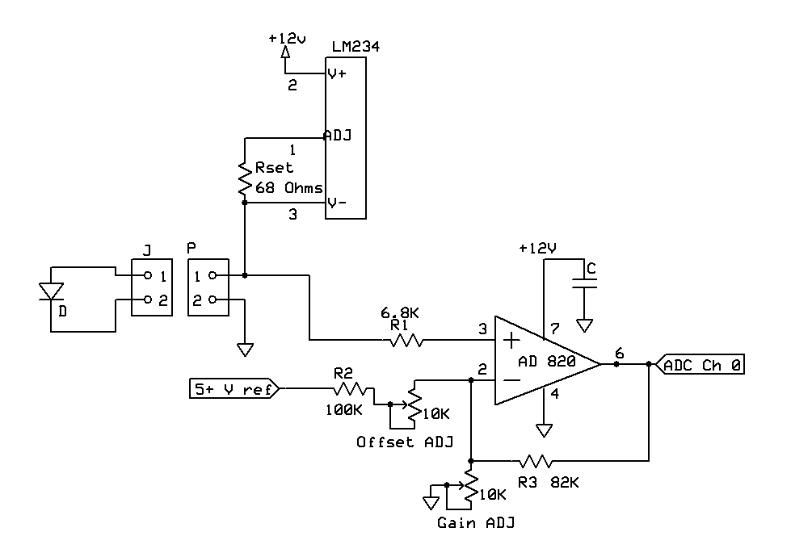Figure 4-2: Temperature Sensor Interface

The interface for the pressure sensor seen in Figure 4-3 requires a constant current supply. An LM234 will be used to supply the 1.5 mA needed to power the sensor [17]. The sensor outputs two different voltages, and the difference of these voltages relates to the pressure. A differential amplifier will amplify the difference of the sensor’s two output voltages into a 0 to 3V range that can be read by the ADC. Precision resistors are required for the 10KΏ and 100KΏ resistors because the gain of each of the sensor’s outputs must be equal. The sensor has an internal resistance; a resistor chosen during prototyping will set the gain of the circuitry. For ease of calibration, a 10kΏ potentiometer will adjust the gain. The output of this circuit will connect to channel one of the ADC.

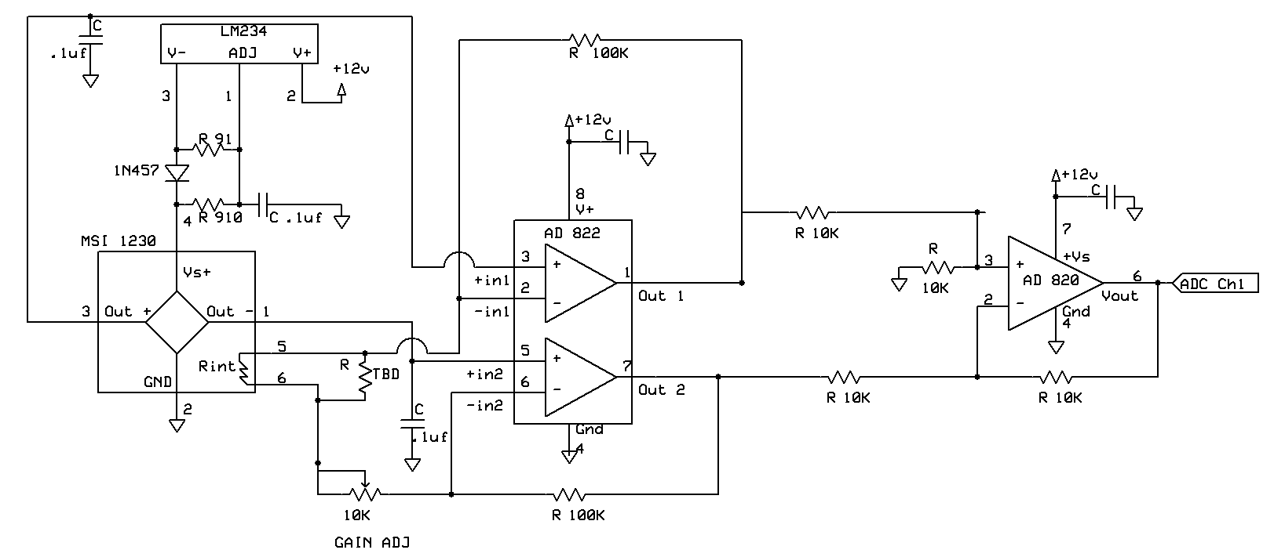
Figure 4-3: Pressure Sensor Interface [24]

Figure 4-4 shows the humidity sensor interface. HIH-5031 sensor will measure humidity and connect to channel two of the ADC. The voltage regulator located on the BalloonSat will to power the sensor. The HIH-5031 outputs a voltage that depends on the voltage used to power the sensor. With 5V used to power, the sensor the output voltage can range from 0.7575V to 3.9375V [18]. To condition this signal from 0V to 3V a gain of 0.9434 will be required and an offset of 0.7134V to be subtracted from the amplified signal. Since the gain is less than one the method used to condition the external temperature sensor signal cannot be used. The signal from the sensor will use voltage division for conditioning. There must be a minimal load of 68KΩ from pin 2 to pin 3 [18]. A 1KΩ potentiometer will adjust the amount that the sensor’s output decreases. The attenuated output will connect to an Opamp follower that buffers the signal. This buffering prevents the impedance of the ADC from affecting the measurement.

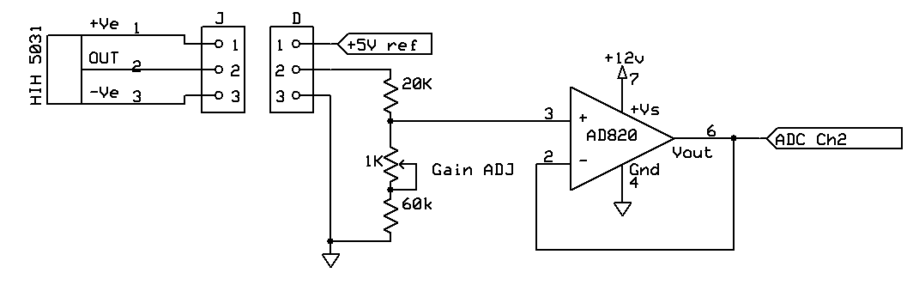
Figure 4-4: Humidity Sensor Interface

Figure 4-5 shows the camera interface. A relay will start and stop the recording of the camera. The BalloonSat will deliver the signal to the relay. A photodiode placed next to the “recording” LED on the camera will detect if the camera is recording. The LED is for risk management, if the camera is supposed to be recording and the LED is off the photodiode will tell the BalloonSat to send a signal to another relay, that will power up the camera.

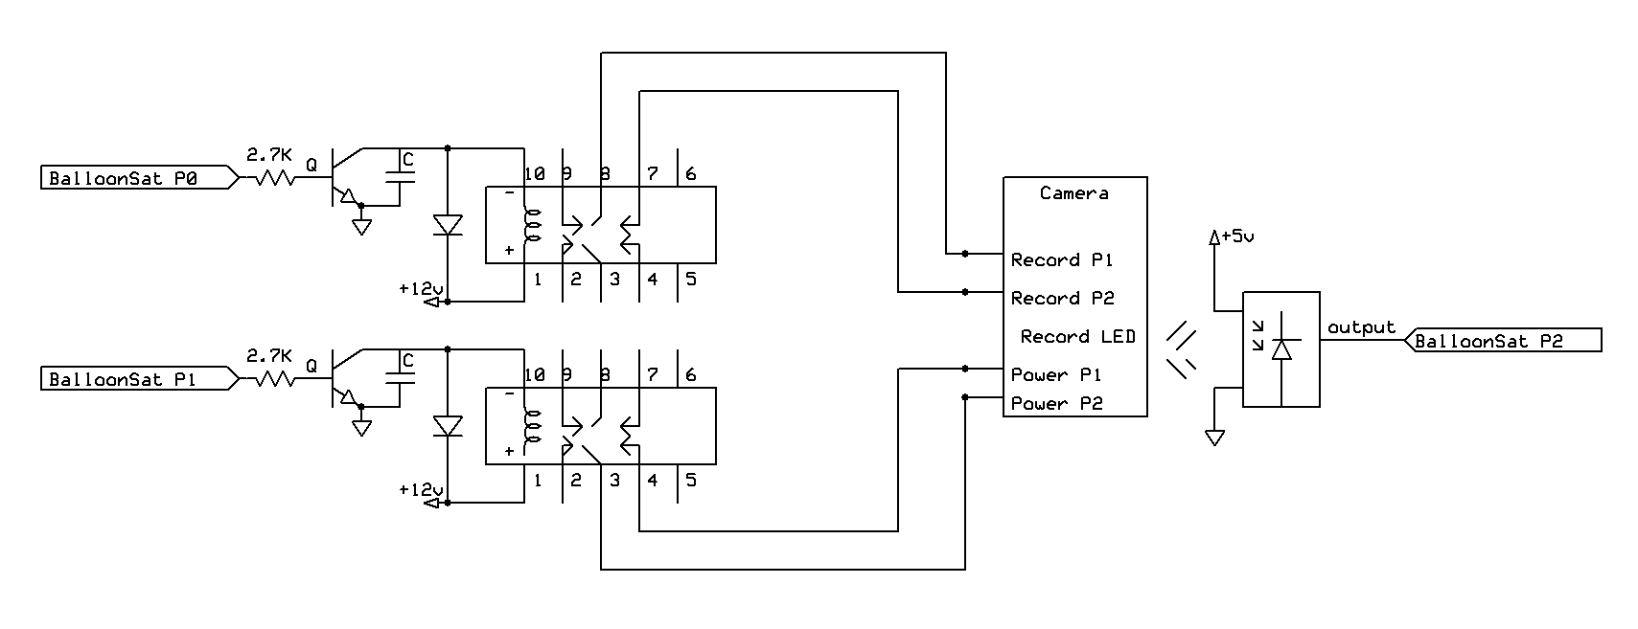Figure 4-5: Camera Interface

4.3.3 Control Electronics

The BASIC Stamp, located on the BalloonSat, is the main controlling unit of the payload. The BASIC Stamp is a simple programmable microcontroller that communicates with the ADC, RTC, and EEPROM through serial interface. The BASIC Stamp initializes the RTC and takes timestamps during flight. The sensors send a voltage to the signal conditioning circuit, which amplifies the voltage to fit in the range of the ADC. The ADC converts the voltage to a digital byte of data. The data will go to the BASIC Stamp and stored in the memory of EEPROM. The BASIC Stamp can also retrieve the data stored in the EEPROM. Figure 4-6 shows a full circuit schematic of the payload.

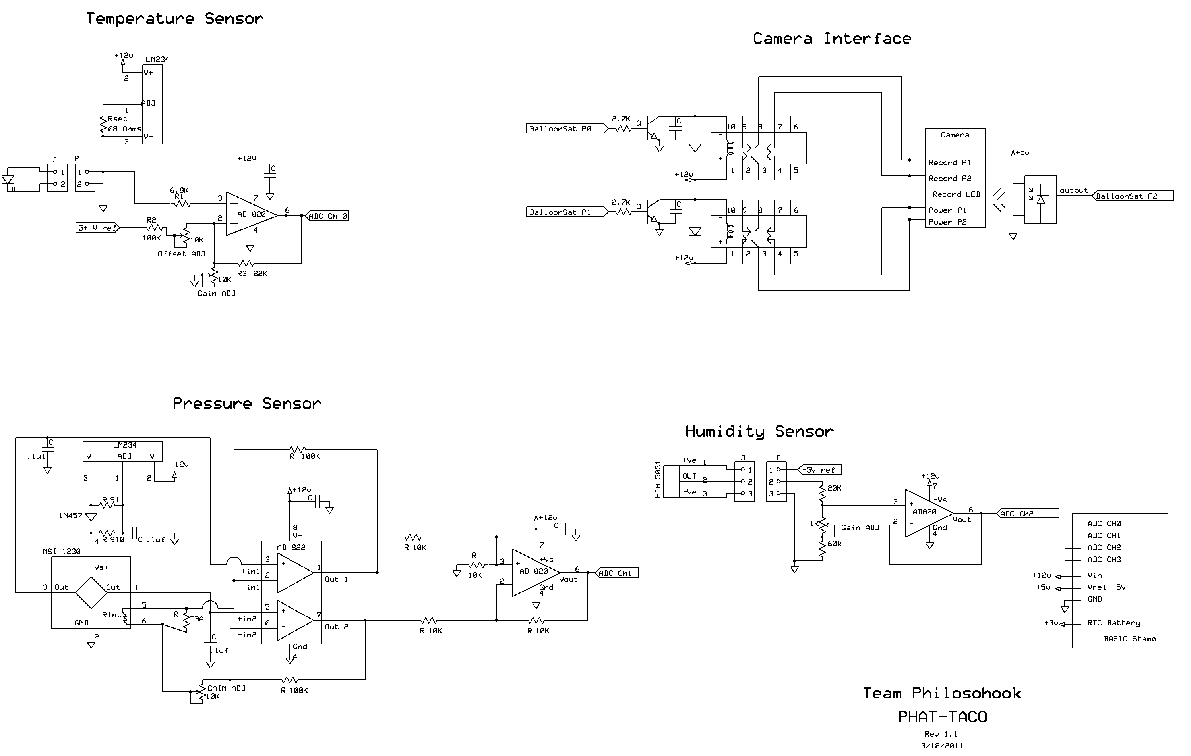
Figure 4-6: Full Circuit Schematic

4.3.4 Power Supply

During prototype testing and calibrations, a bench power supply will power the BalloonSat, all of the sensors, and the sensor conditioning board. The BalloonSat has a voltage regulator that supplies a safe voltage to all components on the BalloonSat. A bench power supply is ideal for testing because all voltages are readily adjustable. Batteries are the best possible power source for flight because they can supply the necessary power and are small in weight (about 10 g each). Fuses will connect to both power supplies, to prevent excess current from destroying any of the components. During prototyping and testing, the exact current measured will determine the size of the fuses required. Figure 4-7 shows a system drawing of the power distribution.
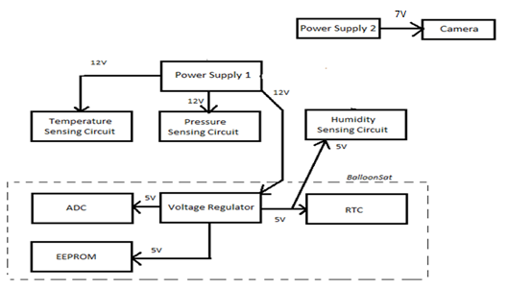
Figure 4-7: Flight Power Distribution

4.3.5 Power Budget

Power Supply 1
Component | Current  (mA) | Voltage  (V) | Power  (mW) | Flight Time  (hours) | Capacity  (mA-hours)
Temperature Interface | 1.2 | 12 | 14.4 | 4 | 4.8
Pressure Interface | 2.1 | 12 | 25.2 | 4 | 8.4
External Humidity Interface | 0.5 | 12 | 6 | 4 | 2
BalloonSat | 52 | 12 | 624 | 4 | 208

Power Supply 2
Component | Current  (mA) | Voltage  (V) | Power  (mW) | Flight Time  (hours) | Capacity  (mA-hours)
Camera | 220 | 7 | 1540 | 4 | 880
Table 4-2: Power budget for power supply 1 and 2 with camera data from Knoxville College [20]

Since the camera drains a large amount of current compared to the other components, two different power supplies are necessary. Power Supply 1 will power all of the sensors, control circuitry, and the BalloonSat. Power Supply 2 will supply power to the camera. Power Supply 1 will consist of eight batteries and Power Supply 2 will consist of four batteries. AA and AAA batteries supply voltages somewhere between 1.3V and 1.8V each, batteries will be dead if lower than 1.3V. Power Supply 1 will range from 10.4V to 14.4V. This range will keep all of the components powered and still be low enough not to damage any component. Power Supply 2 will supply voltages ranging from 5.2V to 7.2V. The camera voltages range from 5V to 7V so the camera will remain powered during flight.

Power Supply 1 will drain 55.8 mA of current and Power Supply 2 will drain 220mA of current. Using these currents and the chart in Figure 4-8 the capacity of Power Supply 1 and Power Supply 2 will be 1200mAh. Power Supply 1 will supply a total of 670mW. By using the graphs in Figure 4-9, a de-rating factor of 0.75 was calculated by taking the ratio of the capacity at a cold temperature and room temperature at 0 ºC. Assuming the same de-rating factor at 0ºC a total de-rating factor of 0.5625 was calculated at -21ºC. The inside of the payload will never get lower than -21ºC (see §4.5) this is an appropriate temperature at which to rate the batteries. Using this de-rating factor the capacity of AAA batteries in Power Supply 1 will be 675mAh. Power Supply 1 requires 223mAh so AAA batteries can supply enough power. Power Supply 2 requires 880mAh and at this de-rating factor AAA batteries cannot supply the power required. Using the AA battery graph in Figure 4-8 the capacity of AA batteries in Power Supply 2 will be 3000mAh. Power Supply 2 will supply a total of 1540mW and by using the graphs in Figure 4-10 the de-rating factor 0.5625 at -21ºC was calculated. Using this factor the capacity becomes 1690mAh. This capacity is high enough to fit the requirements of Power Supply 2. Using these calculations, Power Supply 1 will consist of eight AAA lithium batteries and Power Supply 2 will consist of four AA lithium batteries.

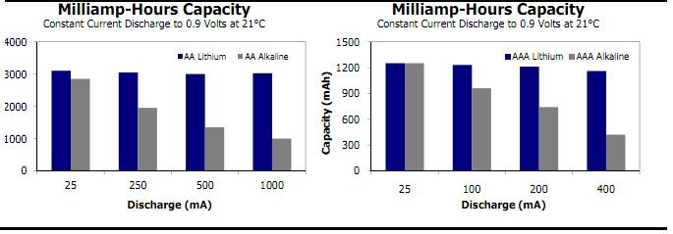
Figure 4-8: Milliamp-Hours Capacity of AA and AAA batteries [21]

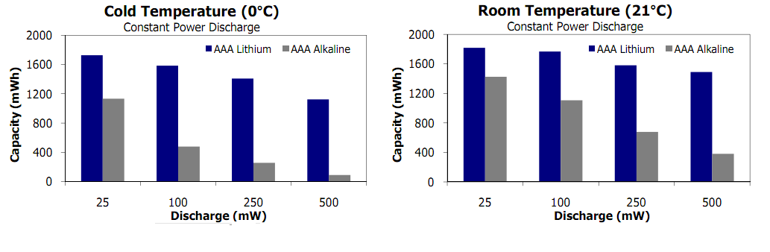
Figure 4-9: Energizer AAA battery capacity at cold and room temperature [21]
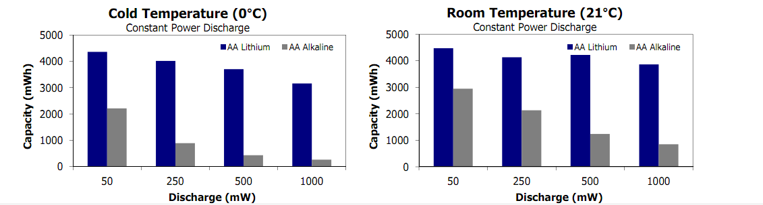
Figure 4-10: Energizer AA battery capacity at cold and room temperature [21]

4.4 Software Design

This section describes the software used for this project. With no software, the PHAT-TACO experiment will fail. Most of the software will run on the BASIC Stamp and will use an EEPROM for data storage. The software must be able to save data and timestamps at the rate specified in the requirements.

4.4.1 Data Format & Storage

There will be two separate data storage devices; The BalloonSat has programmable memory on the EEPROM, and the camera has an external memory card. Two data storage devices are necessary because the camera will record a million times more bytes of data than the pressure, humidity, and temperature sensors.

4.4.1.1 BalloonSat Data Storage

Data from the temperature, pressure, and humidity sensors will be stored on a 32 kilobyte EEPROM. On the EEPROM, there are 32,768 bytes for data storage. In its lifetime, the EEPROM can handle one million read/write cycles and can write one byte of information in 5 ms. A byte is comprised of 8 bits and can store a number from 0-255. The ADC uses whole numbers only and converts a voltage between 0 and 3 volts to a digital byte of information. Based on the range expected and the precision of measurements, each measurement can be stored into one byte.

Measurement of the temperature, pressure and humidity will take 4 bytes because individual sensors use one byte and there are four sensors. We will also use one byte for camera status. One measurement, including sensor data, camera status, and timestamp requires 8 bytes of data. The ascent of the balloon should last 100 minutes and the decent will take about 60 additional minutes. The entire duration will be 9,600 seconds and will require ~1600 data points with an acquisition rate of 1 data point every 6 seconds. Thus, we will need 12,800 bytes of storage. The EEPROM can take data at our specified rate for 408 minutes, or more than 6 hours.

4.4.1.2 Video Data Storage

The two most common forms of data storage for cameras are Secure Digital (SD) cards and flash memory. SD cards are very common and cost 2 dollars per gigabyte (GB) of storage up to 32 GB. The cost for flash memory cards is almost twice the cost of SD cards for the same memory storage. A 3 hour movie shot in 720p (1289x720 pixels) will take approximately 25 GB. This will require a 32 GB card, which costs around 64 dollars.

4.4.2 Flight Software

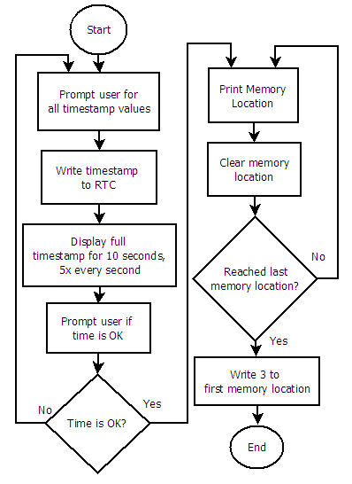
This section has all of the flowcharts and descriptions of the programs. Flowcharts were written using Dia [25]. In the flowcharts, circles indicate the beginning or end of a program or subroutine. A rectangle represents a subroutine call or command. A diamond is a conditional statement, where the program will do something if the condition is met, and something else if the condition is not met.

4.4.2.1 Pre Flight

Figure 4-11 shows the pre-flight software flowchart. Before the flight, the real time clock (RTC) needs to be set. The command “write timestamp to RTC” will be based off of ACES activity P6. The user is prompted for the year, month, day, am/pm, hour, minute, and second. After the user enters the “second” the timestamp is instantly written to the RTC.

After the timestamp is set, the time displays to the screen for 10 seconds, five times per second. This is so that we can check if the timestamp on the RTC matches what we have as the time. After the time is displayed, the software asks the user if the time is acceptable. If the time is unacceptable, the program starts over, but if the time is OK, the program continues.

Figure 4-11: Pre-flight software flowchart

After the software has set the RTC, the program clears all of the memory. It takes a couple of minutes to clear all of the memory locations. The current memory location is displayed to the screen so that the user can monitor the progress. After all of the memory locations have been cleared, the number 3 is stored into the first memory location of the EEPROM. We have reserved the first two bytes to store the address variable. The address variable tells the BalloonSat where to begin writing data. This allows the during flight software to begin writing in the correct memory location upon startup. This is a risk mitigation step that will be further explained in the during flight section (see §4.4.2.2). The EEPROM can only read/write to any one location one million times. Each time we run the flight code to completion, we will write to this location 4,098 times which only allows us to test our code 244 times before that address on the EEPROM stops working correctly.

4.4.2.2 During Flight program and subroutines

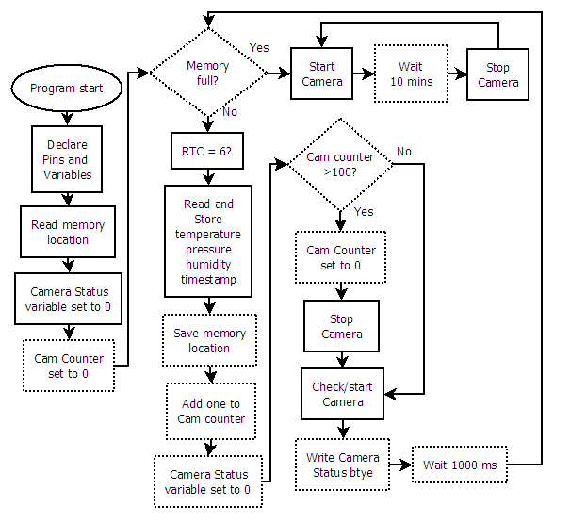
Figure 4-12: During flight software flowchart

Figure 4-12 shows the during flight software. This software must record measurements of the atmosphere once every six seconds. This includes a timestamp of each measurement, data from each sensor, and the camera status byte. This also must control the video camera.

The main section of the program is a loop that runs until the EEPROM is filled with data. One risk during flight is a temporary power outage that resets the BalloonSat. We have added a mitigation step that saves the address of the last memory location written to the EEPROM. When the BalloonSat starts up, it will read this memory location and begin to write data to that location. Without this step, the BalloonSat will restart and begin to overwrite previous data. This memory location is reset during the pre-flight software so that upon start, the during flight software will work as expected.

Since we have determined that we are taking data once every six seconds, the subroutine “RTC = 6?” checks if the “second” value in the RTC is a multiple of six. If it is, then a data point will be taken. If not, then the subroutine will wait 0.2 seconds and test the “seconds” variable again. This system is better than using an internal pause in the EEPROM because this way, the variable amount of time that it takes to read and store the data will not affect the data acquisition rate.
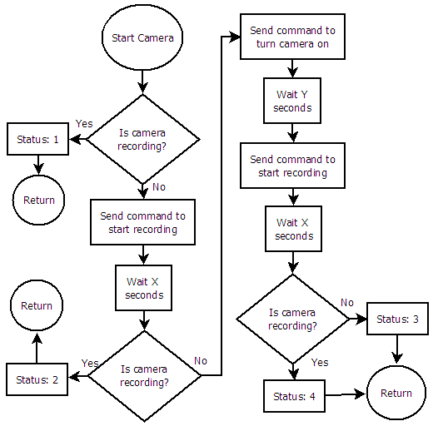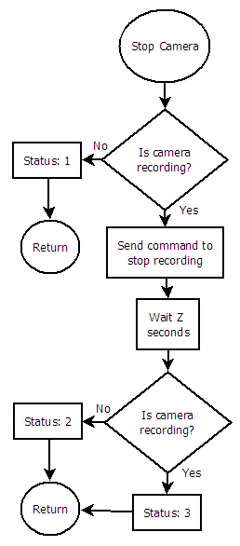
Figure 4-13: Start Camera and Stop Camera subroutines

The BalloonSat is able to control the camera as described in the electrical section (see §4.3.2). The Start Camera and Stop Camera subroutines are how the main program controls the camera. After passing through the Start Camera subroutine, the camera should be recording. After calling the Stop Camera subroutine, the camera will stop recording video. The camera status byte is composed of two nibbles (4 bits), one for start camera and one for stop camera.

The Start Camera subroutine in Figure 4-13 accomplishes several tasks. Firstly, this subroutine checks if the camera is recording. If the camera was recording already, the subroutine ends. If the camera is not recording, the subroutine will send the command to activate the record switch. After sending this command, the subroutine waits “X” seconds for the camera to start recording. This is the time it takes from when the record button is pushed until the hardware can detect that the recording LED has turned on. The exact time of “X” will be determined during calibration. Next, the Start Camera subroutine checks if the camera is recording. If the camera is not recording, this probably means the camera is off, so the software sends the command to turn the camera on. “Y” is the time it takes the camera to start up, and will be determined during calibration. After sending the command to turn the camera on, the BalloonSat sends the command to start recording and waits “X” seconds again. After all of this, if the camera is still not recording, all hope is lost and the subroutine returns.

The Stop Camera subroutine uses a similar procedure to stop the video. If the camera is off, then the subroutine returns, because the camera cannot be recording if the camera is off. If the camera is on, then the Stop Camera subroutine tries to stop the recording.

Start Camera and Stop Camera rely on accurate determination of if the camera is on or off and if the camera is recording or not. The most time spent in these subroutines during one pass in the main loop of the during flight program will be Z + 2X + Y seconds.
Stop Status | Start Status | Meaning | Cause
0 | 0 | Never entered Start Camera or Stop Camera subroutines | Software Glitch or software just started
0 | 1 | Camera recording normally | NORMAL
0 | 2 | Camera was not recording. Recording restarted | Potential hardware malfunction
0 | 3 | Unable to turn camera on or start recording | Power out or memory full
0 | 4 | Camera was off. Turned camera back on. Recording restarted | Temporary power outage or program start
1 | 0 | Entered Stop Camera, but not Start Camera | Software Glitch
1 | 1 | Conflicting measurements of camera is recording | Hardware Malfunction
1 | 2 | Camera was already stopped, then restarted | camera auto shutdown
1 | 3 | Efforts to start recording on camera are useless | power outage or out of memory
1 | 4 | Camera was stopped. Camera shut off, but power was restored and video was turned on | Temporary power outage
2 | 0 | Entered Stop Camera, but not Start Camera | Software Glitch
2 | 1 | Conflicting measurements of camera is recording | Hardware Malfunction
2 | 2 | Camera video stopped, then restarted | NORMAL
2 | 3 | Stop Camera caused shut down. Successfully restarted power and recording | Temporary power outage
2 | 4 | Stop Camera caused shut down. Unable to turn back on | Batteries out
3 | X | Unable to stop recording | Hardware Malfunction
Table 4-3: Meaning and cause of each possible camera status byte

The meanings behind each potential value for the camera status byte are shown in Table 4-3. The entire status byte is initialized to zero before the main loop calls either subroutine.

During flight, the only two statuses that we hope to see are [0,1] (where 0 is the stop status and 1 is the start status), meaning that the camera is recording normally and [2,2], meaning that the video was stopped then restarted. Also, on startup, we should see the status [0,0] because that is what the variable is initialized to. The second camera status should have [0,4] because the camera should be off when the software starts.

- Program to calibrate X:
  - Declare Pins/Variables
  - Send command to turn on camera
  - Wait 5 seconds (long enough to ensure that the camera is on)
  - Send command to turn on video
  - Wait X seconds
  - Check if camera is recording or not
  - Debug if camera is recording or not

- Program to calibrate Y:
  - Declare Pins/Variables
  - Send command to turn on camera
  - Wait Y seconds
  - Send command to turn on video
  - Wait X seconds
  - Check if camera is recording
  - Debug if camera is recording

- Program to calibrate Z:
  - Declare Pins/Variables
  - Send command to turn on camera
  - Wait Y seconds
  - Send command to turn on video
  - Wait X seconds
  - Wait 1 second
  - Send command to turn off video
  - Wait Z seconds
  - Check if camera is recording
  - Debug if camera is recording

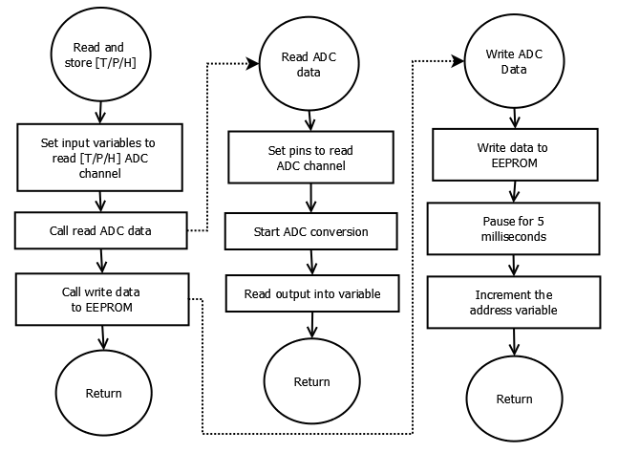
Figure 4-14: Take data subroutines

Figure 4-14 shows the subroutine to take temperature, pressure, or humidity data. The only difference between the subroutines is the pins are set to read different channels of the ADC. The Read ADC data and Write ADC data are very similar to the subroutines given in ACES activity P5 “Interfacing to a serial ADC”. The address variable, which stores the address of the next location to write to the EEPROM, is incremented in the write ADC subroutine. The address variable is also written to the first two bytes of the EEPROM for reasons discussed previously.

The write ADC data subroutine will be called 8 times and will take approximately 80 milliseconds. The “RTC=6” subroutine could take 200 milliseconds. The Stop and Start Camera subroutines could take almost no time to complete, or they could take up to Z + 2X + Y seconds. There is also a 1 second pause at the end of the main loop for the during flight program. As long as the sum of all of these times is less than 5.8 seconds, the program will take data at the required rate of one data point every six seconds.

4.4.2.3 Post Flight program
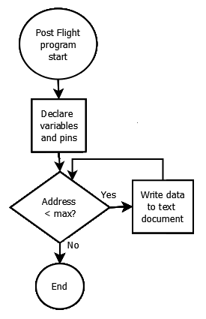
The post flight software shown in figure 4-15 will display the data delimited by commas. We will use Term232, a windows 32 terminal emulator program, to import the output to a plain text file. From this file, we can copy and paste the data into Microsoft Excel. Excel has the capabilities to perform the conversion from raw ADC counts to percent relative humidity, temperature, and pressure based on calibration data.

LaACES management will provide a flight profile of altitude vs time. From this profile, we can determine the altitude of each measurement.

Figure 4-15: Post-flight software flowchart

4.5 Thermal Design

The payload will fly for approximately four hours reaching an altitude of about 30.5 km. During flight, the payload will pass through extreme temperature conditions. Based on information gathered in the science background, the payload will have to survive temperatures ranging from approximately -70ºC to 30ºC.

The sensors in the payload need to be able to operate properly in these extreme conditions. Based on information gathered from a component's data sheet, its maximum and minimum operational temperatures determined its thermal operating range (Table 4-5).

Device | Upper Temperature (ºC) | Lower Temperature (ºC)
ADC, RTC, BASIC Stamp, EEPROM | 85 | -40
Pressure Sensor | 85 | -20
Humidity Sensor | 85 | -40
Temperature Sensor | 200 | -65
Camera | 100 | -40
Energizer Lithium Batteries (AA, AAA) | 60 | -40
Table 4-4: BalloonSat device ranges

Thermal tests are necessary in order to assure that our payload remains within operating range for the sensors. Initial thermal tests used the LaACES Thermal Flight spreadsheet [22].

The LaACES Thermal Flight spreadsheet calculates what the internal temperature at thermal equilibrium. This is the steady-state solution for the thermal properties of our payload. These equations assume that the majority of heat exchanged is in the form of radiation.
Our calculations assume that the time of launch is 7:00 AM in late May. The electronics generate approximately 2 W of heat. The approximate absorptivity and emissivity of the payload is the same as white paint. The foam is 2 cm pink insulating foam and the absorptivity and emissivity of white paint are a close approximation. The calculated radius converted the surface area of the box to an equivalent sphere.
Based on all of these assumptions and simplifications, the equilibrium temperature of the payload at maximum altitude will be approximately -3.9 °C and at the coldest temperature, approximately 10 km, in inner temperature of the payload should be -4.1 °C. The payload will almost never be in thermal equilibrium with the environment because the payload will always be ascending or descending. The rate at which the payload cools will also be a factor in the temperature of the payload. Additionally, clouds reflect infrared light, so when the payload is above clouds, the temperature will increase.
According to the initial calculations, the interior of our payload should get no colder than -4.1 ºC, which is well within the operating range of all the sensors. At this time, there is no need for an additional heating source. These calculations should be justified after thermal testing completion.
4.6 Mechanical Design

This section describes Team Philosohook’s mechanical layout, payload weight, mechanical stresses and design, and materials. The mechanical layout describes the shape and size of the payload in order to ensure that the components are safe during flight and landing. Due to constraints of the balloon used to fly the payload, the payload must not weigh more than 500 g. The payload’s design also takes into account thermal conditions and landing stress. Vacuum, thermal, and shock tests are necessary to verify the safety and structural integrity of the payload.

4.6.1 External Structure

The payload box, constructed of pink insulation foam, will take on the shape of a regular hexagonal cylinder as shown in Figure 4-16 because it is the most efficient balance of volume and structural integrity. The payload will have a bottom glued in place. The box will also have a lid fastened with Velcro to allow for easy component retrieval after testing and flight. The box will have two holes 17 cm apart to run through the height of the payload structure to allow for strings that attach to the balloon vehicle. The lid will have two holes, one to allow the temperature and humidity probes to take the external readings and one for the camera to take video. The payload will measure 10 cm in height in order to allow adequate room for the internal structure of the payload.
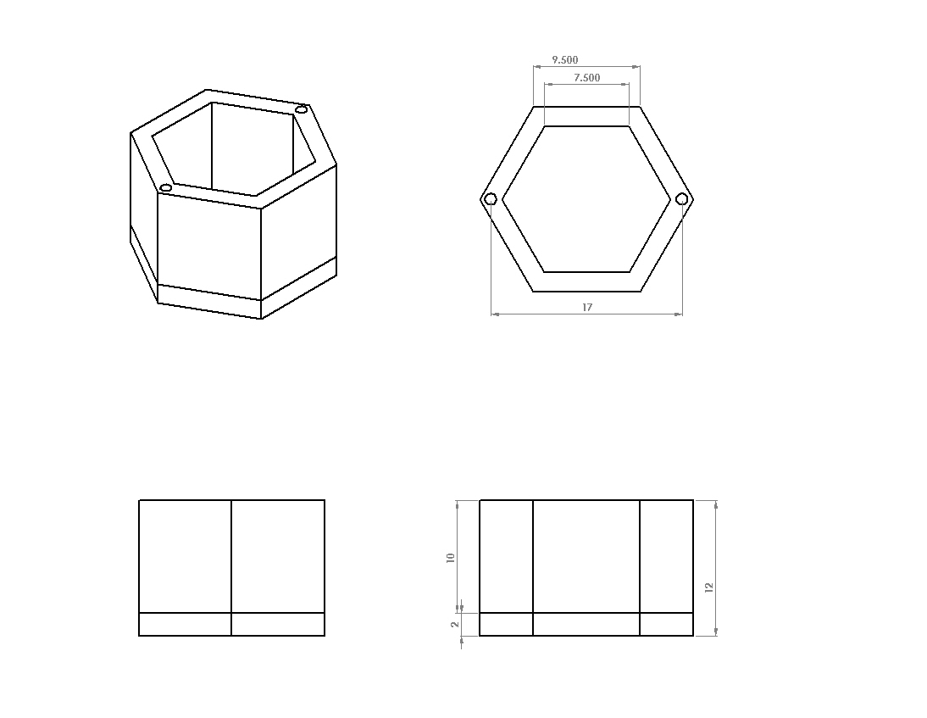
Axonometric
Top
Front
Side
Figure 4-16: Shows the external structure of the payload

4.6.2 Internal Structure

The internal structure of the payload includes the BalloonSat with sensors, the power supplies, the signal conditioning board and the camera as shown in Figure 4-17. A piece of basswood will secure the BalloonSat with the signal conditioning board and the pressure and internal temperature sensors to the bottom of the payload box. The external temperature and humidity sensors will be outside the payload box to collect the external data. The lid will hold the camera within a cutaway designed the hold the camera securely. Velcro will fasten the camera in place to hold the lens steady. A shelf or insert of basswood or foam is an option to reduce the risk of the camera dislodging during flight. Basswood will secure the battery packs to opposite walls inside the payload placed closest to its component connection so that the connecting wires will be as short as possible. Component placement will help accomplish an even distribution of weight

Axonometric
Top
Side
Front
Figure 4-17: Front Cut Away with measurements in centimeters.

4.6.3 Weight Budget

The weight budget for this project is 500 g. Table 4-6 shows the weight of each components measured or estimated based on individual prototypes with error, and weight acquisition method.

Component | Weight (g) | Uncertainty (+/-g) | Measured or estimated
BalloonSat | 66.3 | .05 | Measured
Power Supply 1 | 62.2 | .05 | Measured
Power Supply 2 | 119.1 | .05 | Measured
Signal Conditioning Board and sensors | 65 | 5 | Estimated*
Foam Structure | 100 | 15 | Measured
Camera | 92.4 | .05 | Measured
Total | 505 | 28
Table 4-6: Weight budget
*Estimated weight from the sensor data sheets

5.0 Payload Development Plan

For our project to move to the FRR stage all of the specifications must be known. This includes prototyping the circuitry and payload design. We will purchase sensors for temperature, pressure, and humidity in order to use them for prototyping such as how much power is needed, how the signal must be conditioned, and how much memory is needed for this project. We will test circuitry on a solderless breadboard before being integrated onto the BalloonSat to ensure proper functionality. Finally, we will make a prototype of the payload box in order to make sure that it stays within the size constraints of the testing chambers and the balloon vehicle.

5.1 Electrical Design Development

- Build prototype on solderless breadboard
- Test and calibrate sensors to determine actual accuracy and measurement capabilities.
- Perform shock and thermal tests on each sensor

5.2 Software Design Development

- Adapt pre-existing or write new software for each program
- Load programs into a test BalloonSat board
- Debug program and repeat previous step as necessary
- Build temporary prototype to solder less breadboard
- Compare software output to hardware input to check for consistency

5.3 Mechanical Design Development

In order to complete the final mechanical drawings, component layout, and weight table required for the FRR we must build a prototype payload box and submit it to shock, thermal, and vacuum tests. If the payload breaks under the shock test then the shape of the payload must be reconsidered for one that can withstand stress better. When going through the thermal test, if any of the electronic components, such as the sensors, malfunction inside of the box then we will add more insulation or choose sensors that can operate at lower temperatures. Also, if any of the components, including the electronic components, sensors, and even the box itself, malfunction or break due to the low pressure, new components will have to be selected and integrated into the payload that work in extremely low pressure environments. When all of these tests have been performed and the payload box and circuitry prove to function as expected in the established environmental parameters, the individual components will be measured for an accurate final weight.

5.4 Mission Development

To move closer towards a flight-ready payload, several issues need to be investigated. First, we will calibrate the sensors to the proper ranges of values we expect to encounter. We will also test the components to see if they will function during the balloon flight conditions with thermal and vacuum tests. A chart must be developed to progress mission development towards FRR including prototyping, fabricating, calibrating, and testing.

6.0 Payload Construction Plan

In order to prepare for launch the construction plan will initially focus on the external structure of the payload box. Then the focus will move to the individual components. All the sensors will interface to the BalloonSat, which in turn will connect to power source 1. A circuit board containing the sensors will interface with the BalloonSat through the ADC channels. Then a wire will connect the BalloonSat to power source 1. Once system tests to ensure that all the connections function properly are complete, the circuit board containing the sensors will mount on the BalloonSat. Then the focus will move to the camera. A wire will connect the camera to power source 2. Then the camera circuit board will interface with the BalloonSat by soldering connections. Next, the components will be in the payload box for final testing. This testing will ensure that the payload can withstand the expected atmospheric conditions and the impact of landing. Then collection and analysis of pre-flight data to help prevent future risk.

6.1 Hardware Fabrication and Testing

First, fabrication of the mechanical system, including the construction of the payload box, will take place. Once construction is complete the box will undergo thermal, shock and vacuum testing. During box testing, work will begin on the electrical and software components of the payload. Each of the temperature, pressure and humidity sensors will be prototyped separately on a solderless breadboard once the sensor becomes available. Then fabrication of circuits shall begin and they will interface to the BalloonSat. The software will be written and tested until it runs and prints data successfully. Then the software will be loaded onto the EEPROM of the BalloonSat and then testing of software and electronics will begin to make sure they work together properly. Finally, the assembled components will the placed in the payload box for final thermal, shock and vacuum testing.

6.2 Integration Plan

Individual tests for each system are necessary and when once systems connect to each another, the joint system needs testing to ensure the new system works properly. Once prototyping is completed and all of the subsystems have been tested and fabricated, the systems must integrate into a working payload. First, the sensors and camera will connect to the sensor conditioning and control system. The sensor conditioning and control system contains the circuitry to condition the output of the sensors into a value readable by the ADC. This system also contains the controls to power the camera and to start and stop the recording of the camera. Then this system will interface to the BalloonSat, which contains the internal temperature sensor, ADC, BASIC Stamp, EEPROM and RTC. Then the power system will attach to the system. Finally, all of the systems will be inside the mechanical system, which will complete the payload integration.

6.3 Flight Software Implementation and Verification

We must test the software on the BalloonSat to ensure that the software meets the PHAT-TACO requirements. The software must take data every six seconds, and must be able to monitor and control the video camera.

The first step in testing the software is to verify that the RTC can accurately keep time for at least 24 hours. In the pre-flight software, when the time is set, the program displays the time. From this, we can check if the time synchronized with a reference time. Before flight, we must synchronize the time with the GPS tracker, but for testing purposes, we can just use any clock with a second hand. To verify that the RTC can maintain the time for at least 24 hours, we can set the time, then wait for 24 hours, then check the time on the RTC. We will check the time by using a version of the pre-flight software that does not write the time or overwrite the data.

Since we have multiple identical BalloonSats, we can use one for software testing, and one for sensor calibration. The software testing ensures that we accurately convert the volts measured by the ADC into counts and saved every six seconds. To do this test, we will setup an input voltage to one of the ADC channels using a potentiometer. We will measure the voltage with a digital multimeter and then we will compare the voltage to the output of the software.

Several tests must be done to determine if the during flight software can control the camera as expected. Additionally, the camera status byte must correspond to what is physically happening to the camera.

Tests that must be done:
- RTC can accurately keep time for 24 hours
- RTC can be set to within one second accuracy
- Check data is saved every six seconds
- Check ADC readout is accurate for each channel
- Software powers on the camera on startup
- Software starts recording video on startup
- If camera power is disconnected, then reconnected, the software must turn the camera back on and start taking video again
- Camera video is restarted once every ten minutes
- Camera status must be accurate for the above camera tests

6.4 Flight Certification Testing

The payload we will build has to survive a series of tests that mimic conditions it will experience during the LaACES balloon flight. During the flight, our payload will experience a temperature range of 30°C to -70°C, a pressure range of 760mmHg to 6mmHg, and a deceleration from 6m/s to 0m/s. To produce these conditions, we will use a shock test, thermal test, and vacuum test. During each test, we will power up the payload to match the conditions of each specific test. If the payload survives each test and collects data without interruption, we can ensure that the payload will survive the balloon flight. Any problems found in testing will be noted and resolved.

To verify proper securing of all subsystems and to ensure that they can undergo the forces involved with a balloon flight, the completed payload will be shock tested. The group will place the two external sensors into the payload to protect them from being crushed. With the lid taped down, team members will drop the payload from a height of 10 feet. This should cause the velocity to increase to around 7m/s, faster than we except. Afterwards, we will remove the lid to check all components and note any shifting. Better fastening methods will be investigated if shifting of components occurs.

The group will also perform a thermal test for which the payload will be powered on and placed in various temperature environments. Based on the NOAA data, we will place the payload first in the LaACES lab for 10 minutes at approximately 20°C, a refrigerator for 15 minute at approximately 0°C, a freezer for 20 minutes at approximately -20°C, and then a dry ice cooled environment for 20 minutes at approximately -70°C[2]. Afterwards, the payload shall return back to a freezer for 15 minutes, a refrigerator for 15 minutes, and finally the LaACES lab for 10 minutes. (see appendix for calculations)

We will perform a vacuum test for which the payload will be powered on and placed into a sealed vacuum chamber. In order to simulate the ascent, the pressure inside the chamber will be decreased by 15mmHg increments each minutes until a vacuum of 80mmHg is reached at which point the pressure will be decreased by 3mmHg increments each minute. Once a pressure of 6mmHg has been reached, the process will be reversed to stimulate the descent of the payload.

6.4.1 System Testing Procedures

Shock Test Procedures:
- Power up payload
- Run preflight software
- Run during flight software
- Drop from the height of 10 feet onto the floor
- Remove the BalloonSat from box
- Run post-flight software
- Analyze and verify data

Thermal Test Procedures:
- Power up payload
- Run preflight software
- Run during flight software
- Place the camera, battery pack and the BalloonSat in the payload box
- Let the BalloonSat collect data at the LaACES lab for 10 minutes
- Place the payload in the refrigerator for 15 minutes
- Move the payload box to the freezer for 20 minutes
- Move the payload box to the dry ice container for 20 minutes
- Move the payload box to the freezer for 15 minutes
- Move the payload box to the refrigerator for 15 minutes
- Move the payload box to room temperature for 10 minutes
- Connect the BalloonSat with the computer using the serial cable
- Run post-flight software
- Analyze and verify data

Vacuum Test Procedures:
- Power up the payload
- Run preflight software
- Run during flight software
- Place the battery pack, the BalloonSat, and the camera in the box
- Place the box in the vacuum chamber
- Make sure the vacuum chamber is sealed tight and the pressure gage is turned on.
- Decrease the pressure by 15mmHg per minute
- At 80mmHg, decrease the pressure by 3mmHg per minute
- Stop the pressure chamber at 6mmHg
- Remove the box from the vacuum chamber
- Run post-flight software
- Analyze and verify data

7.0 Mission Operations

We must take appropriate precautions in order to successfully fly the PHAT-TACO experiment on May 24th, 2011 in Palestine, Texas. This includes several procedures, such as extensive testing and calibrating, before flight to mitigate any risk that makes our payload unflyable. In addition, we will instigate measures to assure that the payload can safely fly and recover our payload.

7.1 Pre-Launch Requirements and Operations

Before launch, we will put several procedures in place to ensure payload flyability. We will calibrate each of the sensors to give us equations for the respective temperature, pressure, or humidity based on ADC counts. Furthermore, we will test the camera to make sure it can survive and take video of the entire flight under cool temperatures and low pressures. Software must be written and tested to make sure it properly stores data from the sensors onto the EEPROM and that the camera properly saves video to its internal SD card. Tests must also be done to ensure that our selected batteries will survive the duration and extreme conditions of the flight so that all components are powered for the full flight time. Before launch, we will load the software to the EEPROM and the two power sources will each receive a set of new batteries. Also, on the day of launch, weight of the balloon and vehicle and distance from the payload to the balloon will be measured. Additionally, a checklist ensuring all pre-flight procedures are done will be checked to ensure the payload’s readiness.

7.1.1 Calibrations

To calibrate each sensor, we will perform tests to determine the outputs from just the sensors. We will take measurements across each sensor using a volt meter while exposed to a set battery voltage and environmental conditions. The group will use these to determine the conditioning circuits we will need to create in order to properly use the ADC’s 0-3V range. Once the conditioning circuits are constructed, we shall perform second calibrations to compare the conditioned outputs to the actual values they represent.

For the temperature sensor, we will use a PASCO SF-9616 multimeter to measure the temperature in various environments. First both our sensor and the SF-9616 will measure the LaACES lab temperature. Next, the payload and SF-9616 will placed in a container with no dry ice. Team members will steadily increase the amount of dry ice in the container and record both the ADC value and the SF-9616 value. This will continue until the SF-9616 reaches -50°C, at which point it is no longer accurate. After data collection is complete, we will input the data into an Excel spreadsheet and calculate the correlation between the ADC values and the collected information.

The relative humidity is the amount of water vapor in air, divided by the maximum amount of water vapor that the air could possibly hold (saturation pressure or SP). The saturation pressure changes as a function of temperature. As temperature increases saturation pressure also increases. There is no exact mathematical relationship for this relationship, only experimentally determined fits. One empirical fit to the temperature-saturation pressure relationship is:
SP = 6.112 exp (17.67T/(T+243.5))

Where T is in °C and SP is saturation pressure in mb. This equation has a range of -35 to 35 °C and an accuracy of ±0.1 % [26]. We can use this relation to calibrate the humidity sensor.

In a large sealed container with liquid water present, the air inside of the container will become saturated. If we remove the water from the container, then change the temperature, the saturation pressure will change, but the actual amount of water vapor will remain unchanged. If we assume that the water was originally saturated, we can calculate the relative humidity by measuring the temperature. If we use the starting temperature of 0°C, the original saturation pressure will be 6.122 mb, and the conversion from temperature is:

RH = 100 * exp (-17.67T/(T+243.5))

Starting from saturated air at 0°C, then increasing the temperature to 35°C will have an RH range from 100 to 10.9 %rel. All components in the BalloonSat will work in these temperature ranges. If the temperature sensor is calibrated, then the measurements from the temperature sensor can be used in the equation above to measure the relative humidity.

To calibrate the pressure sensor, we will use the vacuum chamber in the LaACES lab. After activating our payload, the pressure sensor will measure ground-level pressure. Team members will adjust the variable resistor on the payload to set ground-level pressure near the top of the 3V range in order have more accurate readings at lower pressures. Next, the group will place the payload in the vacuum chamber and the chamber activated. At various intervals, teammates will stop the vacuum chamber and allowed the pressure sensor to take several measurements at that pressure as well as record the pressure indicated by the vacuum chamber pressure gauge. Team members will use these data points to create a line of best fit for the pressure sensor’s output voltage versus absolute pressure.

Finally, we will calibrate the camera. First, one team member will start the camera to make sure it is operating properly. Next, another teammate holding a ruler will stand at a prescribed distance away from the camera. The first team member will take video for about 1-2 minutes in order to collect data. After data collection is complete, both team members will use the pixels of the camera images to determine the angular resolution of the pixels.

The BalloonSat will control the video camera, but the camera takes a significant amount of time to execute commands sent by the BalloonSat. Because of this delay, the software must have set timing delays to control the camera properly. We must determine time “X” which is the time between when the BalloonSat sends the command to start recording and when the LED light is detected by the BalloonSat. In addition, we must determine time “Y” which is the time between the command to turn on the camera and the camera having the ability to receive the command to start recording. Finally, the “Z” time is the time between when the BalloonSat sends the command to stop recording and the BalloonSat detects the recording LED is off. After the during flight software is completed, this program can be simplified to determine the x, y, and z times. These new programs will take less than one hour to make. Flowcharts for these are in the text of the next section.

7.1.1.1 Calibration Procedures

Calibration of temperature sensor
- Both payload and PASCO SF-9616 with temperature sensor will be placed in room temperature environment, a refrigerator, a freezer, an icebox with dry ice (without HOBO), taken outside, and brought back to room temperature for 10-15 minutes each.
- Graph collected ADC voltage data versus PASCO SF-9616 measured temperatures, using data points once each sensor reached equilibrium in an environment.
- Calculate line of best fit
Calibration of pressure sensor
- Allow the payload pressure sensor to measure the pressure of the lab
- Place payload in vacuum chamber
- Run vacuum and read pressure of the chamber, stopping at certain points for 2-3 min each
- Record values of payload at each pressure
- Graph collected ADC voltage data versus actual measured pressures
- Calculate line of best fit
Calibration of humidity sensor
- Place both temperature and humidity sensor in sealable container.
- Allow both temperature and payload humidity sensor to collect humidity data from saturated environment of cooler containing ice water at 0°C in unsealed container
- Seal container
- Move both temperature and payload humidity sensor to heated environment to collect information
- Wait until payload reaches room temperature
- Graph collected ADC voltage data versus calculated humidity
- Calculate line of best fit
Calibration of camera
- Start camera to see if operating properly
- Teammate holding ruler will stand at distance 2 meters away from the camera
- Teammate will stand away from camera for 1-2 minutes
- Team members to find amount of information contained in each pixel will examine camera video.
Camera timing calibration:
To determine time X:
- Connect camera to BalloonSat
- Connect BalloonSat to PC
- Run X calibration software
- Adjust value of X until debug says that the camera is recording
To determine time Y:
- Connect camera to BalloonSat
- Connect BalloonSat to PC
- Run Y calibration software
- Adjust Y until debug says that camera IS recording
To determine time Z:
- Connect camera to BalloonSat
- Connect BalloonSat to PC
- Run Z calibration software
- Adjust Z until debug says that camera is not recording

7.1.2 Pre-Launch Checklist

Event | Time needed | T- minus to launch
Verify that all components are ready for flight and operational. | 10 minutes | 2 days
Load the correct pre-flight software and during flight software. | 5 minutes | 12 hours
Put in the appropriate fresh batteries for each of the power sources and make sure each power source is connected to its appropriate components. | 2 minutes | 1 hour
Place components in payload and tape the lid shut and check to make sure camera is facing up and through the hole in the lid. | 1 minute | 1 hour
Attach the payload to the launch vehicle and check to make sure it is secure. | 10 minutes | 45 minutes
Take picture from a distance in order to calculated distance from payload to balloon. | 2 minute | 5 minutes
Total Time | 30 minutes
Table 7-1: Pre-launch checklist with expected time needed to fulfill each duty.

7.2 Flight Requirements, Operations and Recovery

Our flight vehicle will be filled with helium such that our ascent rate should be 1000 feet per minute. Our expected flight duration is three hours and we expect the flight to start in the morning. The camera will have enough power and memory to record video of the entire flight. Additionally the EEPROM will have sufficient power and memory for each of our sensors to record data for the entire flight. The camera will need to be facing the balloon for the duration of the flight in order to allow us to calculate its radius. We will also need the altitude of the balloon at all times in order to compare our temperature, pressure, and humidity readings to altitude. We will need the position of the balloon in order to track it so that we can retrieve the payload after landing. The payload vehicle will have two additional payloads to send GPS coordinates of the balloon to LaACES management and a sounding beacon loud enough to hear within several hundreds of feet in case the payload lands in a densely forested area or other area that is hard to navigate through or see. Additionally, these extra payloads are yellow in color and the parachute is multicolored so that they are easier to spot from far away.

7.3 Data Acquisition and Analysis Plan

May 23rd will be the FRR defense, May 24th will be launch and flight operations, the 25th will be a day of data analysis, and on the 26th we will present our science results. Therefore, there is only one day to analyze our data and make a science presentation. In order to fully analyze our data, we will design and test post-flight software. Also, after the balloon launch, we will follow a detailed post-flight data analysis plan. We will not have any spare time to fix any software during the launch trip, so we must ensure that all post-flight software works appropriately. We will already have a science presentation prepared, and we will add in data from the flight the day before the presentation.

7.3.1 Ground Software

Once we remove the BalloonSat from the payload box, we will need to download the data to a computer and save the data into a text document. We will use Term232, a windows terminal emulator, to save the output of the BalloonSat to a text document. During software testing, we will develop a step by step procedure to properly run Term232. From this text document, we will be able to copy and paste the data into our post-flight Excel sheet.

The temperature, pressure, and humidity sensors all have linear outputs. During calibration, we will determine equations that convert ADC counts to temperature, pressure, and humidity. We will set these calibration data into the post-flight Excel sheet. We will use Excel to convert raw ADC counts into temperature, pressure, and humidity measurements. We will also measure errors on the calibrations, which will enable us to calculate the uncertainties in temperature, pressure, and humidity.

$$Temperature=m_{t}(ADC)+b_{t}$$
$$Pressure=m_{p}\left(ADC\right)+b_{p}$$
$$Humidity=m_{h}(ADC)+b_{h}$$
$$Error= {(σ_{m}ADC)}^{2}+ {(σ_{b})}^{2}$$

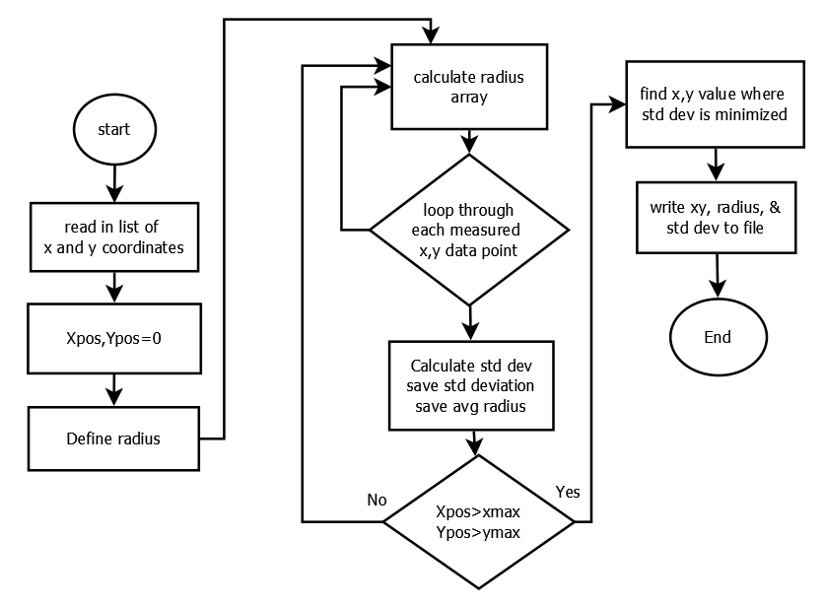
From the altitude measurements, we will calculate the expected temperature, pressure, lapse rate, and density of air. The standard atmosphere depends on sea level measurements of temperature and pressure, which we can calculate from the first measurements, which are near sea-level. After calculating the standard atmosphere and uncertainties, we can see how well our measured values match with the standard atmosphere. Also we will calculate the correlation between humidity and errors between measured temperature and expected temperature.
Figure 7-1: Balloon Radius calculator

To measure the radius of the balloon, the video will be paused every 2 minutes and a screenshot of the video will be placed into MS Paint. In paint, we will note the x and y coordinate (in pixels) of the edge of the balloon for several locations. A program written in C++ will calculate the radius of the balloon from these x and y measurements. This program works by looping through every possible x,y combination and calculating the radius at each point, then calculating the standard deviation of the radius measurements at each point x,y. The radius is where the standard deviation is a minimum. Also, we will watch the video to determine when the payload is passing through a cloud, and record the times that the payload is passing through clouds.

7.3.2 Ground Software Implementation and Verification

We will use two separate computers for data analysis. One computer, called Post Flight Personal Computer 1 (PFPC1), will analyze and download the video data. The other computer, named Post Flight Personal Computer 2 (PFPC2), will analyze and download the BalloonSat data.

Tests that we must do:
- Verify that camera videos can be downloaded to post-flight PC
- Verify that radius calculating program works
- Learn how to use Term232 and write step-by-step instructions on how to use it
- Verify that post-flight software and Term232 can transfer data from the BalloonSat to Excel for data manipulation
- PFPC-1 must have:
  - SD card reader or USB port
  - At least 32 GB open memory
  - A movie player that can support .MOV video format
  - MS paint
  - MS Excel 2011
  - Dropbox
- PFPC-2 must have:
  - VGA input for BalloonSat
  - At least 32 KB of open memory
  - Term232
  - MS Excel 2011
  - Dropbox

During the software testing, we need to determine that the post-flight software can extract the data from the BalloonSat. Additionally, the radius calculating program must be able to calculate the radius of a circle. These will be tested by making a circle of a known radius in MS paint, measuring the x and y coordinates of the edge, putting these coordinates into the radius calculating program, and see if the output matches the known radius. For the BalloonSat post-flight software, we can run the during flight program, then run the post flight program and see if the post-flight program successfully outputs the data stored in the EEPROM.

7.3.3 Data Analysis Plan

After the flight, we have very little time to download, convert, and analyze the data. We must be very efficient with our data processing. Team Philosohook will break into two teams, one for video analysis, and the other for BalloonSat data processing.

Post-flight procedure for Team Philosohook:
- Track and locate payload
- Image payload
- Recover payload
- Disconnect power
- Remove camera
- Remove BalloonSat

After all of those, we will split into two teams; the video processing team will do the following:
- Download Videos to PFPC-1
- Number the videos
- Watch videos in sequence
- For each video
  - Record time (in the video) that the payload passes through a cloud
  - Pause every 2 minutes for radius measurement (also before and after passing through clouds)
    - Pause video
    - Take screenshot of video
    - Paste screenshot into MS Paint
    - Record at least 8 coordinate pairs of the balloon edge
    - Run radius calculating program
    - Record output to Excel sheet
  - Convert time in video to absolute time using data from the BalloonSat (provided by the other team)
  - Convert absolute time into altitude
- Create plot of balloon radius vs. Altitude
- Create plot of when the balloon is passing through a cloud vs. altitude

The BalloonSat data processing team will do the following:
- Connect BalloonSat to PFPC-2
- Set up Term232
- Run post-flight BalloonSat software
- Save raw output to plain text document
- Paste data into post-flight Excel sheet
- Check video status output byte
- Record times that the video restarts and give to the video analyzing team
- To convert raw data into useful data:
  - Convert ADC counts into T,P,H data using calibration equations
  - Calculate T,P,H errors using calibration errors
  - Calculate lapse rate
  - Determine altitude of the layers of the atmosphere from lapse rate
- To calculate US Standard Atmosphere
  - Input heights of the layers into equations
  - Input sea level temperature and pressure into equations
  - Calculate errors based on equations derived in the appendix

After the flight we will do science. Interesting plots would include:
- Temperature vs. Altitude
- Pressure vs. Altitude
- Humidity vs. Altitude
- Lapse Rate vs. Altitude
  - Layers of the atmosphere vs. Altitude
- Relative error of temperature vs. Altitude
- Relative error of pressure vs. Altitude
- Correlation of temperature error with respect to standard atmosphere and humidity vs. Altitude
- Correlation of pressure error with respect to standard atmosphere and humidity vs. Altitude
- Balloon radius vs. Altitude
- Expected radius vs. Altitude (using actual density of the air and weight of the payloads)
- If the payload is passing through a cloud vs. Altitude
- Temperature, Pressure, and Humidity vs. Altitude before and after passing through cloud
- Internal temperature vs. Altitude

After producing all of these plots, we will analyze them and determine what properties of the atmosphere are affected by passing through clouds. We will also determine if there is any correlation between humidity and temperature or pressure. All of these plots will be made using Excel in a final spreadsheet.

8.0 Project Management

The purpose of this section is to ensure this project meets the experiment’s objectives within the allocated schedule and budget. This includes discussion of project direction, authorization, communication, meeting, reviews, record keeping, and monitoring. In order to ensure proper project direction, the team will refer to its purpose, goals, and objectives contained in Sections 1 and 3 of this report. The project manager, in conjunction with the team members, makes major decision. A majority rule vote resolves any disputes. In the case of a tie the dispute will be brought to one of the ACES project managers to settle the dispute.

Team Philosohook meets every Tuesday and Thursday from 6:00 pm until 8:00 pm and Wednesdays from 6:00 pm until 7:00 pm. Team members work additionally at their own discretion in order to meet the project timeline. A log book resides in the ACES lab and each member is required to sign in and briefly describe what they did each time they work. Failure by an individual to uphold their part of the project results in disciplinary action as defined by the team contract.

8.1 Organization and Responsibilities

Member | Responsibility | Email
Hannah Gardiner | Project Management | hgardi1@tigers.lsu.edu
Bill Freeman | Software Design | billfreeman44@yahoo.com
Randy Dupuis | Electrical Design | rdupui4@tigers.lsu.edu
Andrea Spring | Mechanical Design | aspri11@tigers.lsu.edu
Corey Myers | Testing and Implementation | cmyer14@tigers.lsu.edu
Table 8-1: Team members, their responsibilities, and email addresses

8.2 Configuration Management Plan

Any major change in mechanical design, electrical design, or software design will be submitted by the team member in charge of the respective section to the rest of the team members. After discussion of the changes the team will put the design change up to a vote decided by majority rule. If the team cannot reach a consensus or the vote ties, then ACES staff will be contacted to help resolve the issue. The project manager then records the changes in the log book.

8.3 Interface Control

All team members meet in the ACES lab in Nicholson Hall at LSU. Team members consult each other regarding any effects that their section has on another team member’s section if needed. All major changes will be documented in the log book and discussed at team meetings.

9.0 Master Schedule

This section describes how Team Philosohook will organize and manage the effort associated with our payload. Microsoft Project was used to organize our Work Breakdown Structure and Timeline.

9.1 Work Breakdown Structure (WBS)

1.Electronics 12 days
1.1 Electronics Design 6.5 days
1.1.1 Sensor Selection 1.0 days
1.1.2 Parts Selection 1.5 days
1.1.3 Circuit Design 2.0 days
1.1.4 Power budget 1.0 days
1.1.5 Circuit Schematic Drawn 1.0 days
1.2 Electronics Prototyping 6.0 days
1.2.1 Constructing subsystem Prototypes 0.5 days
1.2.1.1 Construct Temperature System Prototype 0.5 days
1.2.1.2 Construct Pressure System Prototype 0.5 days
1.2.1.3 Construct Humidity System Prototype 0.5 days
1.2.2 Test subsystem Prototypes 0.5 days
1.2.2.1 Test Temperature System Prototype 0.5 days
1.2.2.2 Test Pressure System Prototype 0.5 days
1.2.2.3 Test Humidity System Prototype 0.5 days
1.2.3 Develop Sensor Prototype 1.5 days
1.2.3.1 Construct Prototype 1.0 days
1.2.3.2 Test Prototype 0.5 days
1.2.4 Power Supply during flight 1.5 days
1.2.4.1 Finalization of values for Power Supply 1.0 days
1.2.4.2 Interface Power Supply with Prototype 0.5 days
1.2.5 Test Full Prototype 1.0 days
2. Mechanical 16 days
2.1 Design 2.0 days
2.1.1 External Design 1.0 days
2.1.2 Internal Design 1.0 days
2.2 Construction 8.0 days
2.2.1 External Construction 3.0 days
2.2.1.1 Build payload box 2.5 days
2.2.1.2 Cut holes for sensors and camera 0.5 days
2.2.2 Internal Construction 5.0 days
2.2.2.1 Build insert for BalloonSat 2.0 days
2.2.2.2 Install sensors, BalloonSat and camera 3.0 days
2.3 Testing 6.0 days
2.3.1 Sensor and camera testing 2.0 days
2.3.2 Impact testing 1.0 days
2.3.3 Thermal testing 1.0 days
2.3.4 Vacuum testing 1.0 days
3. Software 12 days
3.1 Write Subroutine Flowcharts 3 days
2.1.1 Pre Flight Subroutine Flowcharts. 1 days
2.1.2 During Flight Subroutine Flowcharts 1 days
2.1.3 Post Flight Subroutine Flowcharts 1 days
3.2 Software writing 4.5 days
2.2.1 Pre Flight 1.5 day
2.2.2 During Flight 1.5 day
2.2.3 Post Flight 1.5 day
2.2.4 timing programs 0.25 days
3.3 Testing 4.5 days
2.3.1Pre Flight 1.5 day
2.3.2 During Flight 1.5 day
*depends on electrical prototype
2.3.3 Post Flight 1.5 day
4. Calibrations 10.5 days
4.1 Calibration of temperature sensor. 3.0 days
4.1.1 Temperature conditions set up 1.0 day
4.1.2 Temperature information collection 1.0 day
4.1.3 Temperature information calibrated 1.0 day
4.2 Calibration of pressure sensor. 3.0 days
4.2.1 Pressure conditions set up 1.0 day
4.2.2 Pressure information collection 1.0 day
4.2.3 Pressure information calibrated 1.0 day
4.3 Calibration of humidity sensor. 3.0 days
4.3.1 Humidity conditions set up 1.0 day
4.3.2 Humidity information collection 1.0 day
4.3.3 Humidity information calibrated 1.0 day
4.4 Calibration of camera. 1.5 days
4.4.1 Camera conditions set up 0.5 days
4.4.2 Camera information collection 0.5 days
4.4.3 Camera information calibrated 0.5 days

9.2 Staffing Plan

Primary Roles:
Spokesperson Project Lead – Hannah Gardiner
Mechanical Design Lead – Andrea Spring
Testing and Implementation – Corey Myers
Software – Bill Freeman
Electrical Design Lead – Randy Dupuis
Editing Lead – Hannah Gardiner

Secondary Roles:
Secondary Project Lead – Andrea Spring
Secondary Mechanical Design Lead – Corey Myers
Secondary Testing and Implementation Lead – Hannah Gardiner
Secondary Software – Randy Dupuis
Secondary Electrical Design – Bill Freeman
Secondary Editing – Bill Freeman

9.3 Timeline and Milestones

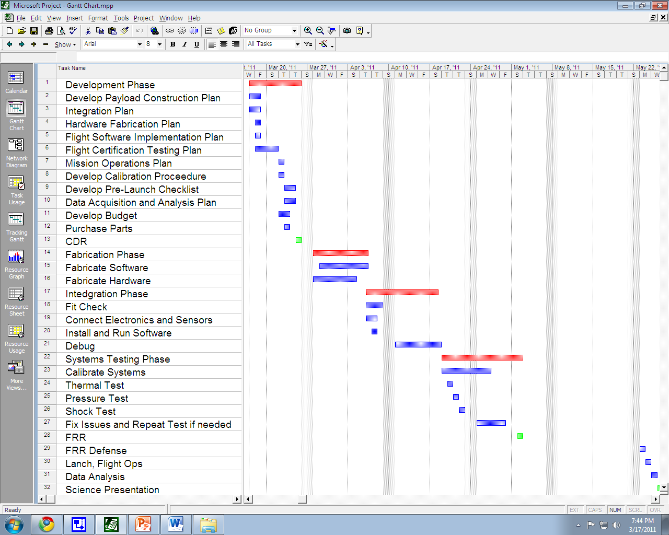
Figure 9-1: Gantt chart showing the overall project timeline

10.0 Master Budget

Item | Source | Manufacturer # | Quantity | Price
Temperature Sensor | DigiKey | 1N457 | 1 | $0.02
Pressure Sensor | TBD | TBD | 1 | $40
Humidity Sensor | DigiKey | HIH-5031 | 1 | $14.11
Risk Contingency | Dr. Guzik | US Mint | 1 | $100
Camera | eBay | Kodak Zx1 | 1 | $40
32 GigaByte SD Card | Amazon | TS32GSDHC10E | 1 | $54
Expanded EEPROM | Paralax | 24AA64 | 1 | $1.50
Batteries (AA) | Thomas Distributing | ENR-L91BP-4 | 4 | $4
Batteries (AAA) | Thomas Distributing | ENR-L92-BP4 | 8 | $8
Additional Camera(s) | eBay | Kodak Zx1 | 1 | $80
Single OpAmp Integrated Circuit | Analog Devices | AD820 | 1 | $2.25
BalloonSat | LaAces Management | bsat12 | 1 | --
 |  |  | TOTAL | $343.88
Table 10-1: Master Budget

Table 10-1 shows our master budget of components, the source at which we will attain them, manufacturer number, quantity, and price. Our total budget thus far is $343.88 which falls within our $500 limit. Our budget also contains a $100 contingency in case new parts are needed. Additionally, we have set aside an extra $80 contingency in our budget for extra cameras in case the camera being used for testing and calibrations breaks beyond repair. Even with contingency, we still have extra room in our budget.

10.1 Expenditure Plan

Component | Price | Status
Temperature Sensor | $0.02 | Acquired
Pressure Sensor | $40 | Acquired
Humidity Sensor | $14.11 | Not Yet Ordered
Camera | $40 | Acquired
32 GigaByte SD Card | $64 | Not Yet Ordered
Expanded EEPROM | $1.50 | Not Yet Ordered
Batteries (AA) | $4 | Not Yet Ordered
Batteries (AAA) | $8 | Not Yet Ordered
Single OpAmp Integrated Circuit | $2.25 | Acquired
BalloonSat | -- | Acquired
Table 10-2: Expenditure Plan shows each component, its price, and status

10.2 Material Acquisition Plan

Many of the materials required for our project are already at our disposal in the LaACES lab. This is very convenient for preliminary testing and calibrations because we save time on waiting on shipping. However, other parts will be attained through online vendors such as eBay, Amazon, Paralax, Thomas Distributing, Analog Devises, and DigiKey. Although we already have some of the components, it is important that we document where we can attain the components in case one or more of the components fail and we need to order more. Additionally, parts we do not have will be ordered shortly after completion of CDR phase.

Material | Quantities | How Acquired | When Needed | When Ordered
BalloonSat | 1 | Supplied by LaACES | Calibration and testing | Already have
Capacitors, wires, resistors, etc. for electronics | 22 | Supplied by LaACES | Calibration and testing | Already have
Styrofoam, Gorilla Glue, & Duct Tape | 50g | Supplied by LaACES | Payload Creation | Already have
1N457 Temperature Sensor | 1 | Supplied by LaACES | Electronics prototyping | Already have
1230 Pressure Sensor | 1 | Supplied by LaACES | Electronics prototyping | Already Have
HIH-5031 Humidity Sensor | 1 | Order Online | Electronics prototyping | Not yet ordered
Kodak Zx1 Camera | 1 | Supplied by LaACES | Electronics prototyping | Already have
32 GigaByte SD Card | 1 | Order Online through Amazon | Software Testing | Not yet ordered
24AA64 Expanded EEPROM | 1 | Order Online | Electronics Development | Not yet ordered
Batteries (AA) | 4 | Order online through Thomas Distributing | Calibrations | Already have
Batteries (AAA) | 8 | Order online through Thomas Distributing | Calibrations | Already have
Table 10-3: Material Acquisition Plan

11.0 Risk Management and Contingency

Likelihood and impact are estimated on a scale of 1 to 5, one being the least likely to happen or the least impact and five being the most likely to happen or the highest impact. Detection difficulty is also estimated on a scale of 1-5, one being the least difficult to detect and five being the most difficult to detect.
System | Risk | Likelihood | Impact | Detection Difficulty | When
Software | - | - | - | -
 | Loading of the wrong program to the payload | 1 | 5 | 3 | Pre-Flight
 | Forget to load program into payload | 1 | 5 | 1 | Pre-Flight
 | Running out of memory | 4 | 3 | 1 | During flight
 | Temporary power failure | 3 | 4 | 4 | During flight
Mechanical | - | - | - | -
 | Payload box breaks upon landing | 3 | 3 | 2 | Touchdown
 | Lid comes off of box during flight | 1 | 4 | 3 | During flight
 | Lack of insulation | 1 | 5 | 3 | Box production
 | Payload breaks during flight due | 1 | 5 | 5 | During flight
Electrical | - | - | - | -
 | Condensation forming on payload electronics | 4 | 4 | 5 | During flight
 | Components fail during flight | 2 | 4 | 2 | During flight
 | Sensor fail during flight | 2 | 4 | 2 | During flight
 | Short circuit in payload | 2 | 4 | 4 | During flight
 | Bad connection during fabrication | 2 | 4 | 4 | Fabrication
 | Camera failure | 2 | 5 | 3 | During flight
Other | - | - | - | -
 | Going over money budget | 1 | 5 | 3 | Fabrication
 | Going over weight budget | 2 | 5 | 3 | Fabrication
 | Payload enters clouds | 3 | 3 | 2 | During flight
 | Solar flares | 1 | 4 | 5 | During flight
 | Ice forming on payload | 2 | 4 | 5 | During flight
 | Balloon Vehicle is lost | 1 | 5 | 1 | Touchdown
Table 11-1 Risk Management

Risk Event | Response | Contingency | Trigger | Who is Responsible
Loading of the wrong program to the payload | Reload | Check program before flight | Lapse in concentration | Bill
Forget to load program into payload | Reload | Check payload before flight | Lapse in concentration | Bill
Running out of memory | Restart program before launch | Use larger EEPROM | Starting flight program too early or late balloon launch | Bill or ACES management
Temporary power failure
Payload box breaks upon landing |  | Shock test |  | Corey, Andrea
Lid comes off of box during flight |  | Duct tape to secure the lid
Lack of insulation |  | Thermal Test |  | Corey, Andrea
Payload breaks during flight due |  | Vacuum test |  | Corey, Andrea
Condensation forming on payload electronics |  | Coat parts and secure with foam
Components fail during flight |  | Test all components before flight |  | Corey,
Sensor fail during flight |  | Test all sensors before flight |  | Corey
Short circuit in payload |  | Perform shock test on components |  | Corey
Bad connection during fabrication |  | Follow schematic when building payload |  | Andrea, Randy
Camera failure |  | Check camera functionality and battery pack before flight |  | Corey,
Going over money budget |  | Choose less expensive parts |  | Hannah
Going over weight budget |  | Choose lighter parts |  | Hannah
Payload enters clouds |  | Visual conformation with camera to determine enter and exit time
Solar flares |  | Check solar activity for predicted influence
Ice forming on payload |  | Ample foam to insulate payload |  | Andrea
Balloon Vehicle is lost
Table 11-2 Risk Contingency

12.0 Glossary

%rel Percent relative humidity
AC Alternating Current
ADC Analog to Digital Converter
Atm Atmosphere
CCD Charge Coupled Device
CDR Critical Design Review
CMOS Complementary metal oxide semiconductor
EEPROM Electrically Erasable Programmable Read-Only Memory
ESRL Earth System Research Laboratory
FRR Flight Readiness Review
GMD Global Monitoring Division
GPS Global Positionaing Satellite
HD High Definintion
Hum Humidity
km Kilometer
LaACES Louisiana Aerospace Catalyst Experiences for Students
LSU Louisiana State University
NASA National Aeronautics and Space Administration
NOAA National Oceanic and Atmospheric Administration
PDR Preliminary Design Review
RH Relative Humidity
RTD Resistant temperature detectors
TBD To be determined
TBS To be supplied
Temp Temperature
USAF United States Air Force
V Volts
WBS Work breakdown structure

Appendix
Propagation of errors in the US Standard Atmosphere and PHAT-TACO measurements:

A.1 Temperature and pressure errors

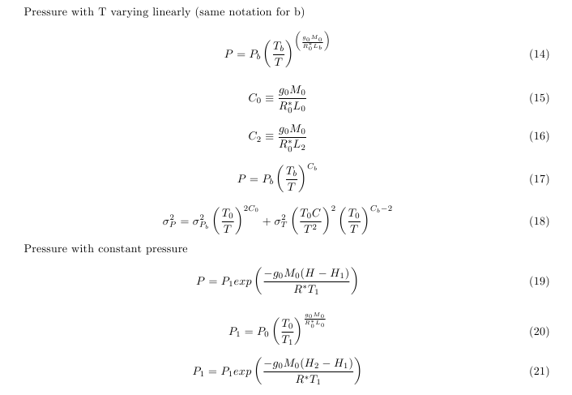

A.2 Lapse rate error propagation:

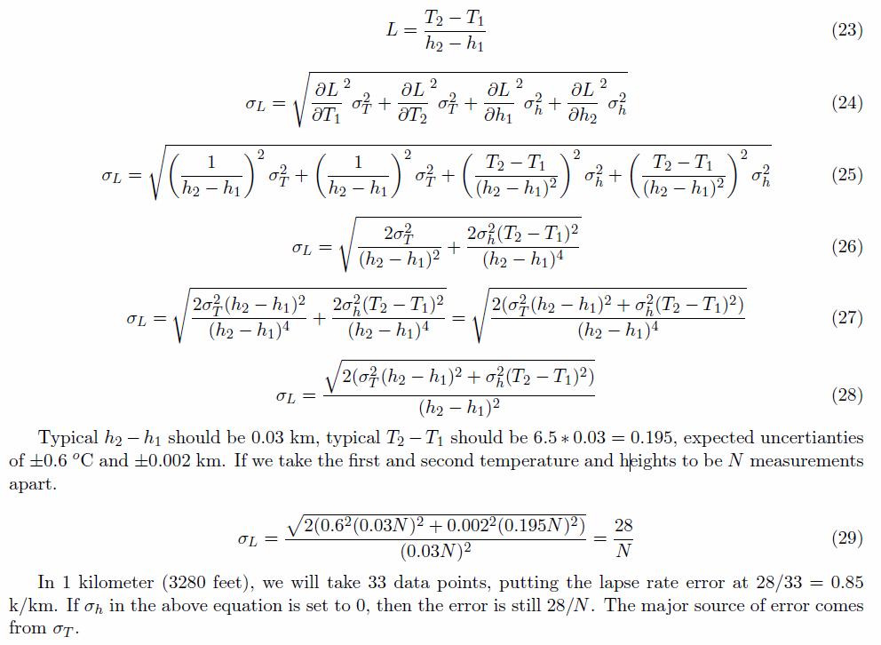

A.3 Errors in the radius measurement:

The difference between measured radius and actual radius can be calculated using:

R_{meas} - R = r/cos(arctan(r/(L+r))) – R

R (m) | L(m) | r(m) | Rmeas (m) | delta R (cm)
1 | 4 | 0.980581 | 0.999405 | 0.0595347
2 | 4 | 1.897367 | 1.993148 | 0.68518917
3 | 4 | 2.757435 | 2.978174 | 2.182649507
4 | 4 | 3.577709 | 3.956422 | 4.35775999
5 | 4 | 4.370786 | 4.930739 | 6.926057375
1 | 8 | 0.993884 | 0.999934 | 0.006616778
2 | 8 | 1.961161 | 1.998809 | 0.119069399
3 | 8 | 2.894291 | 2.994691 | 0.530920306
4 | 8 | 3.794733 | 3.986296 | 1.370378341
5 | 8 | 4.666728 | 4.973375 | 2.662450515
Table A-1: Typical errors in radius measurement based on geometry

Table 3-3 shows error calculated based on a distance to the payload of either 4 or 8 meters, and the radius of the balloon varying from 1 to 5 meters. Due to memory availability, the best resolution we could hope to get would be about 1 cm/pixel. If the balloon is far enough away from the payload, the limiting factor will be the resolution of the camera, not the geometry.

A.4 Balloon Radius equation derivation:

The gravitational constant changes by less than one percent during flight, so we assume it is a constant. When the balloon reaches constant velocity, all the forces acting on the balloon are equal.

F_{b} = F_{bal} + F_{He} + F_{pay} + F_{drag}

In this equation, F_{b} is the buoyant force (lift from balloon), F_{bal} is the weight of the balloon, F_{He} is the weight of the helium in the balloon, F_{pay} is the weight of the payloads, and F_{drag} is the force of drag on the balloon.

D_{Air}*V*g = m_{bal}*g + m_{He}*g + m_{pay}*g + k*D_{Air}*(π*r²)*S²

In this equation, D_{Air} is the density of air in kg/m³, V is the volume of the balloon in m³, g is gravitational acceleration in m/s², m_{bal} is the mass of the balloon in kg, m_{He} is the mass of helium inside of the balloon in kg. The density of air can be estimated from the US Standard Atmosphere model, radius of the balloon will be measured from the video, volume of the balloon can be calculated from the radius, the mass of the balloon is 2000 grams, the mass of the payloads should be known before launch, g is 9.81m/s², k is a geometrical factor which is between 0.07 and 0.5 for spheres [25], and the speed should be constant and can be calculated from GPS data. The radius, volume, and density of air should be the only factors that change with height. Terms that do not vary with altitude have been grouped into the constant C.

D_{Air}*V*g = C + k*D_{Air}*(π*r²)*S²

(4/3)*π*r³*g*D_{Air}= C + k*D_{Air}*(π*r²)*S²

(4/3)*π*r³*g*D_{Air} - C - k*D_{Air}*(π*r²)*S² = 0

The above equation has one real solution and we will test if the above equation holds true throughout flight.

A.5 Temperature system testing:

Figure A-1: Temperature as a function of altitude from NOAA data taken on May 23, 2010 from Fort Worth, Texas [2]
The following diagram shows the temperature relation to altitude from the NOAA data in figure A-1. The barred regions show the approximation of how long the payload spent in each temperature range. From the approximations and assuming constant ascend velocity of 1000 feet per minute, we can calculate the time to spend in each temperature range.
For 20°C: (2.5 km)*(1min/1000 ft)*(3280 ft/1 km)=8.2 minutes
For 0°C: (3 km)*(1min/1000 ft)*(3280 ft/1 km)= 9.8 minutes
For -20°C: (4.5 km)*(1min/1000 ft)*(3280 ft/1km)= 14.76 minutes
For -70°C: (4 km)*(1min/1000 ft)*(3280 ft/1km)= 13.12 minutes
For the decent, the payload will be traveling at approximately 5500 feet per minute. Thus, the equations are similar, only varying in the speed that is use.

For -70°C: (4 km)*(1min/5500 ft)*(3280 ft/1km)= 2.38 minutes
For -20°C: (4.5 km)*(1min/5500 ft)*(3280 ft/1km)= 2.68 minutes
For 0°C: (3 km)*(1min/5500 ft)*(3280 ft/1 km)= 1.8 minutes
For 20°C: (2.5 km)*(1min/5500 ft)*(3280 ft/1 km)=1.5 minutes
Because the decent times are so short, we will increase the time spend in each temperature region so that the payload can be tested in longer conditions.

